**AWS VPC and EC2 Setup and Management: 25 Tasks Using AWS UI & AWS CLI**

1. **Create VPC**

**Using AWS Management Console:**

* Navigate to the VPC Dashboard.
* Click on Create VPC.
* Choose VPC Only.
* Enter a Name and CIDR block (e.g., 10.0.0.0/16).
* Click Create.

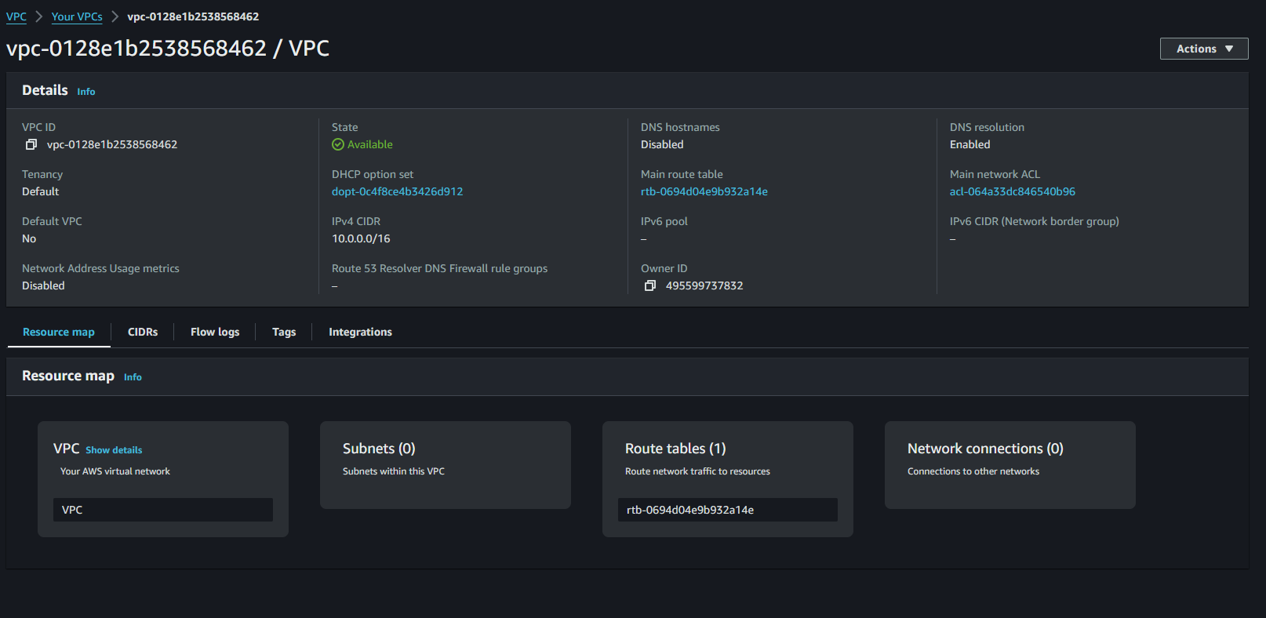

**1. Create a VPC**

* aws ec2 create-vpc --cidr-block 10.0.0.0/16

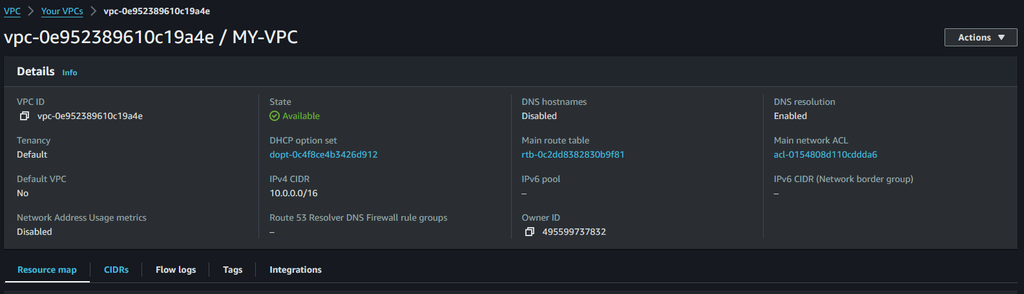

**2. Create 6 subnets (3-public, 3-private)**

**Using AWS Management Console:**

1. Go to Subnets in the VPC Dashboard.
2. Click Create Subnet.
3. Choose your VPC and select Availability Zones.
4. Enter Subnet Name, CIDR block (e.g., 10.0.1.0/24 for public and 10.0.2.0/24 for private).
5. Repeat this step to create 3 public and 3 private subnets.

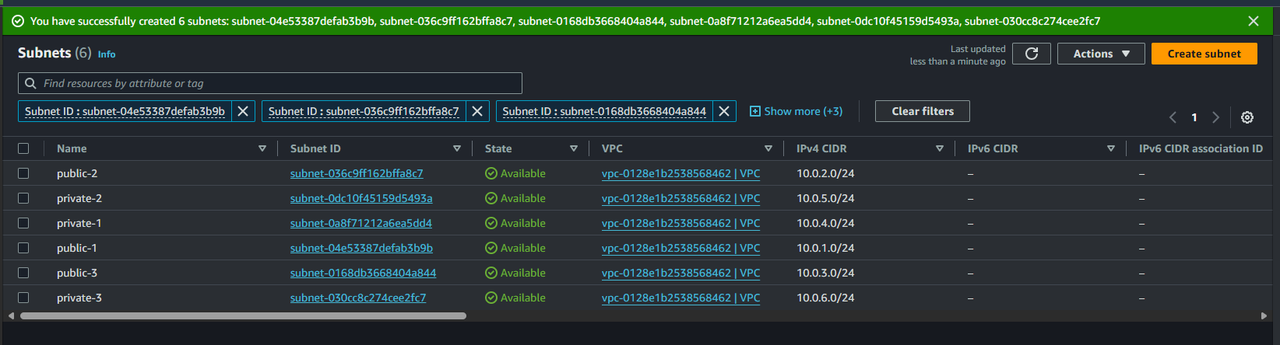

**2. Create 6 Subnets (3 Public, 3 Private)**

* aws ec2 create-subnet --vpc-id vpc-08d016758d4f0009a--cidr-block 10.0.1.0/24 --availability-zone us-west-2a
* aws ec2 create-subnet --vpc-id vpc-08d016758d4f0009a--cidr-block 10.0.2.0/24 --availability-zone us-west-2b
* aws ec2 create-subnet --vpc-id vpc-08d016758d4f0009a--cidr-block 10.0.3.0/24 --availability-zone us-west-2c

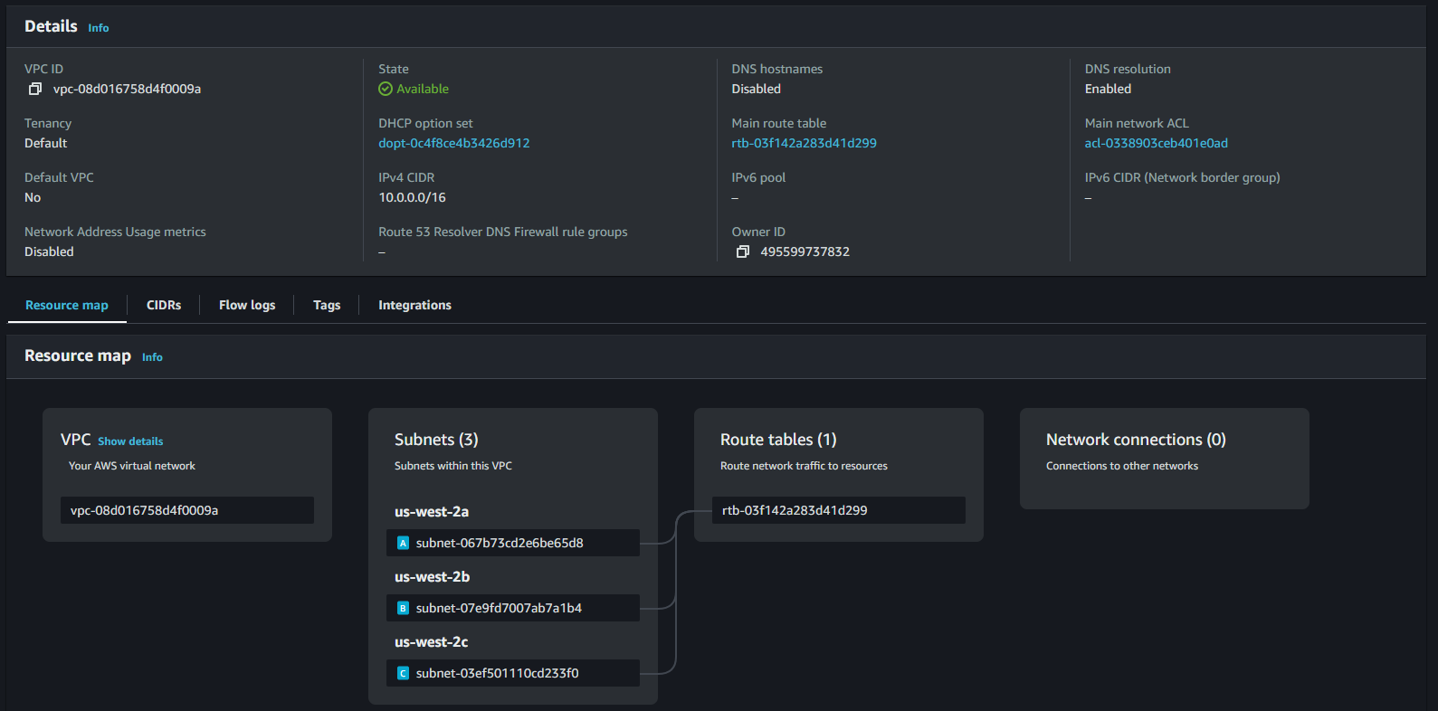

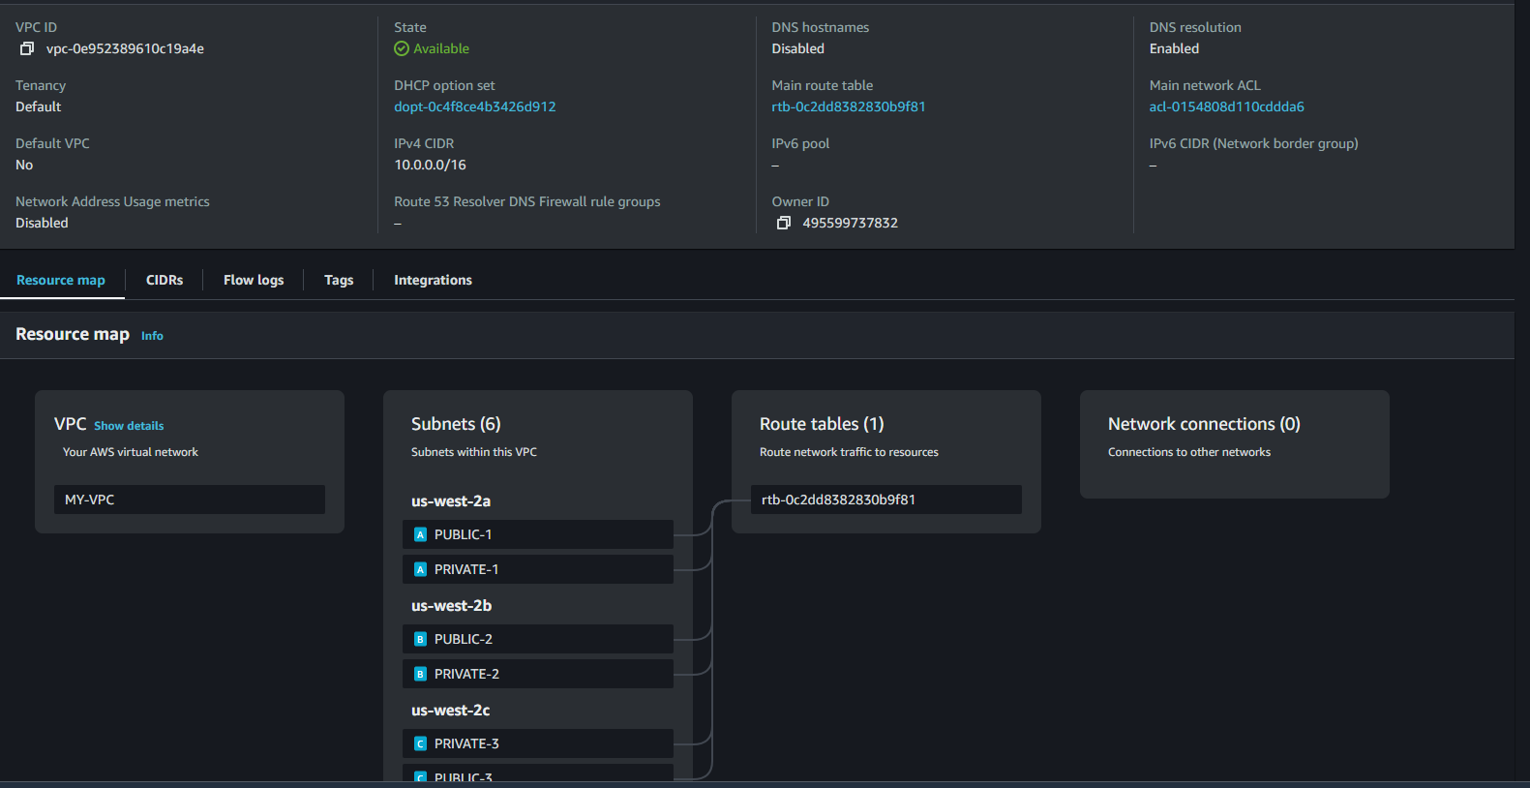

**3. Create Public and Private Route Tables**

**Using AWS Management Console:**

* Navigate to Route Tables.
* Click Create Route Table.
* Select your VPC, enter a Name (e.g., PublicRouteTable), and click Create.
* Repeat for the Private Route Table.

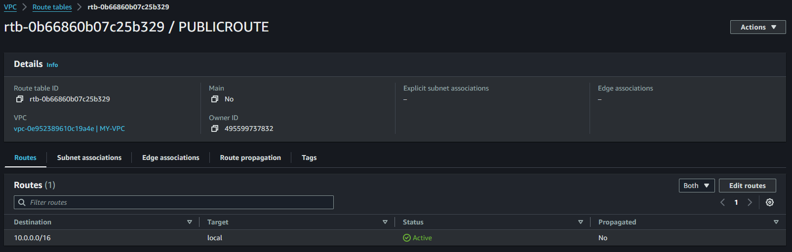

**Private Route Table**

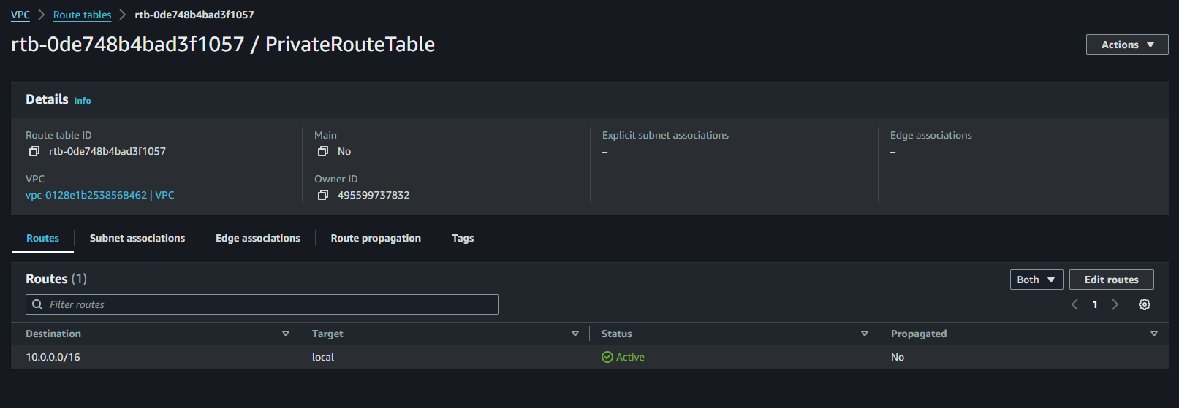

**3. Create Public and Private Route Tables**

* aws ec2 create-route-table --vpc-id vpc-08d016758d4f0009a --region us-west-2

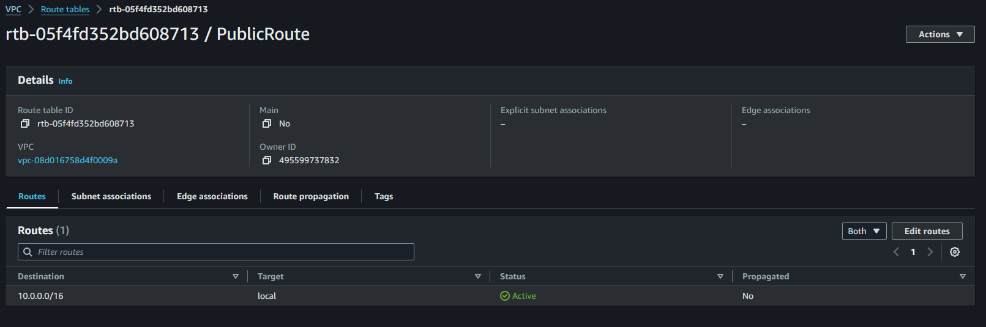

* aws ec2 create-route-table --vpc-id vpc-08d016758d4f0009a --region us-west-2

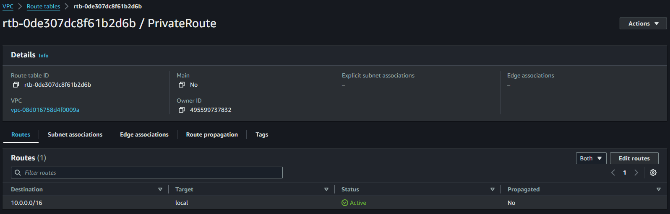

**4. Create an Internet Gateway (IGW)**

**Using AWS Management Console:**

* Go to Internet Gateways.
* Click Create Internet Gateway.
* Enter a Name and click Create.

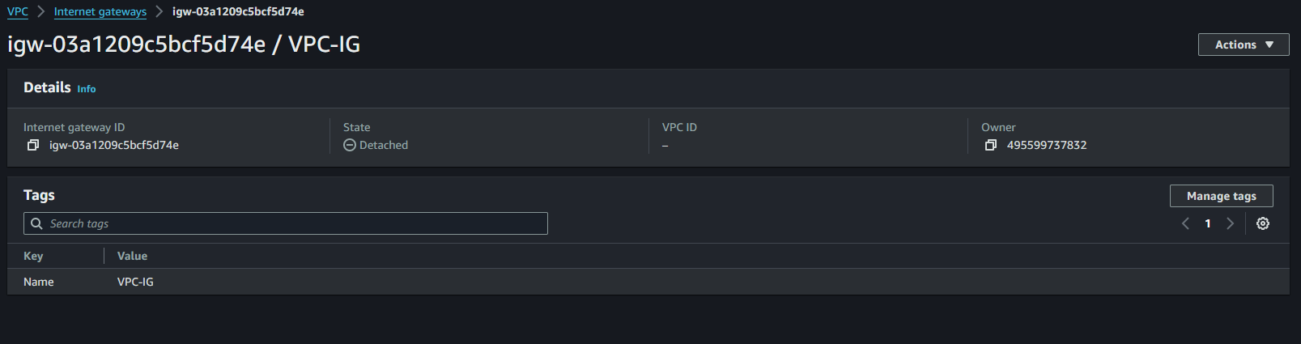

**4. Create an Internet Gateway (IGW)**

* aws ec2 create-internet-gateway --region us-west-2

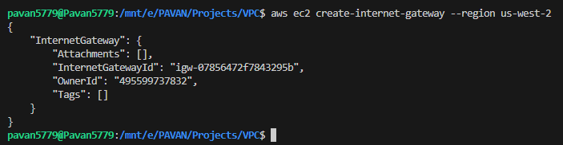

**5. Attach the IGW to the VPC**

**Using AWS Management Console:**

* Select your newly created IGW.
* Click Actions > Attach to VPC.
* Select your VPC and click Attach.

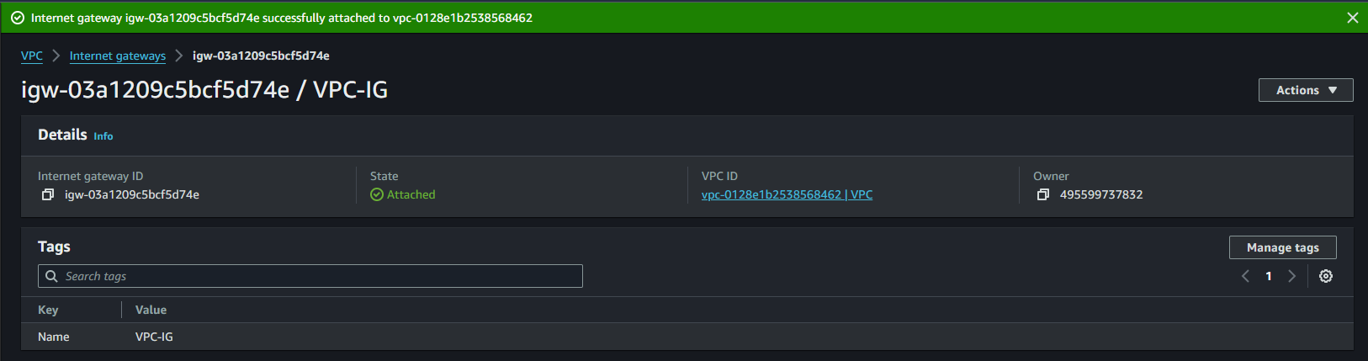

**5. Attach IGW to VPC**

* aws ec2 attach-internet-gateway --internet-gateway-id igw-08ba8718256379ddf --vpc-id vpc-08d016758d4f0009a --region us-west-2

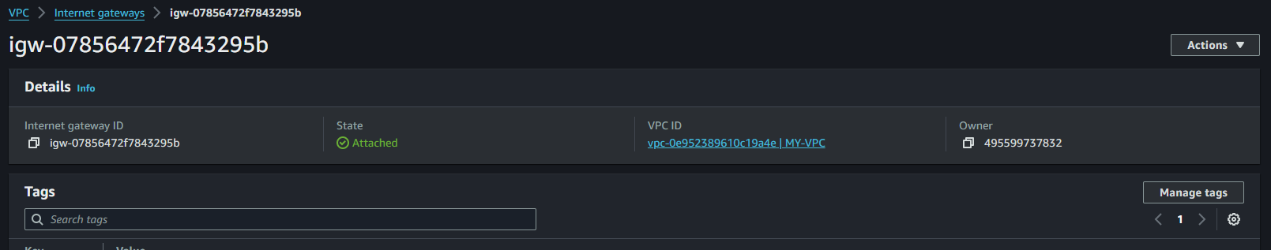

**6. Add a Route to Public Route Table to Send Traffic via IGW**

**Using AWS Management Console:**

1. Select the Public Route Table.
2. Click on the Routes tab and then Edit Routes.
3. Add a route with Destination 0.0.0.0/0 and Target your IGW.

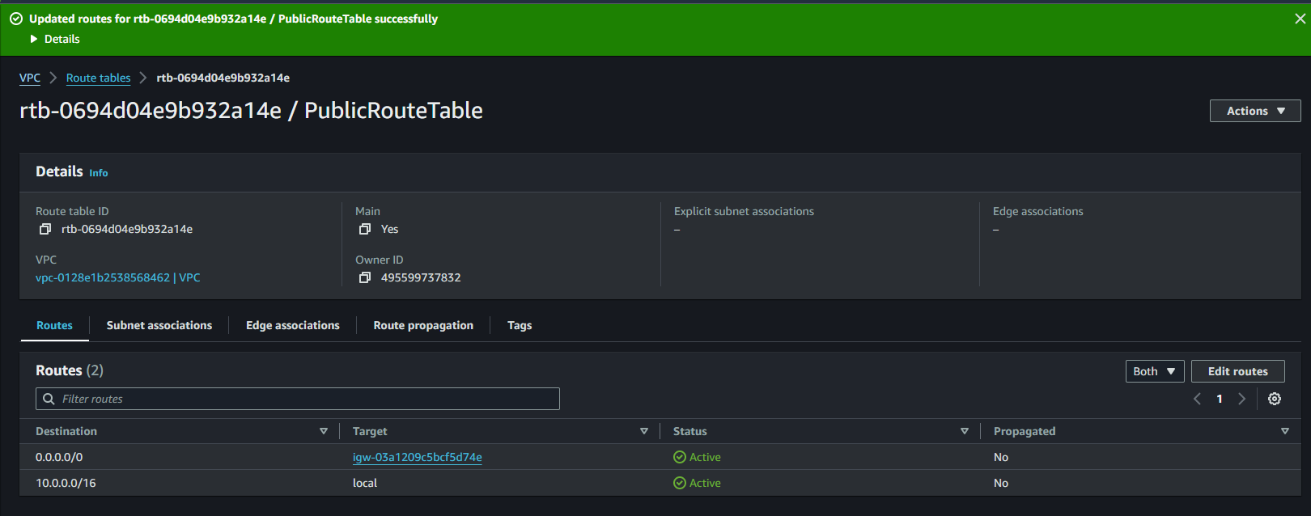

**6. Add Route to Public Route Table (via IGW)**

* aws ec2 attach-route --route-table-id rtb-05f4fd352bd608713 --destination-cidr-block 0.0.0.0/0 --gateway-id igw-07856472f7843295b --region us-west-2

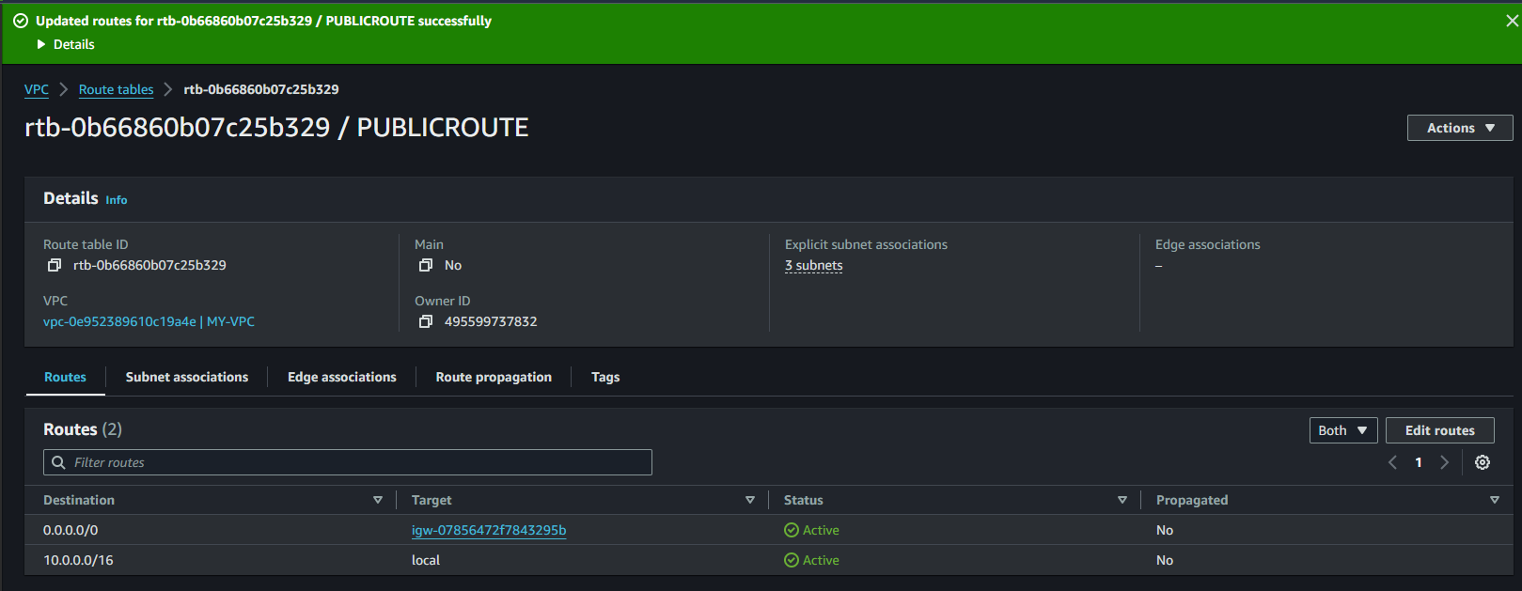

**7. Associate All 3 Public Subnets to the Public Route Table**

**Using AWS Management Console:**

* Go to the Subnets tab in your Public Route Table.
* Click Edit Subnet Associations.
* Select all 3 public subnets and save.

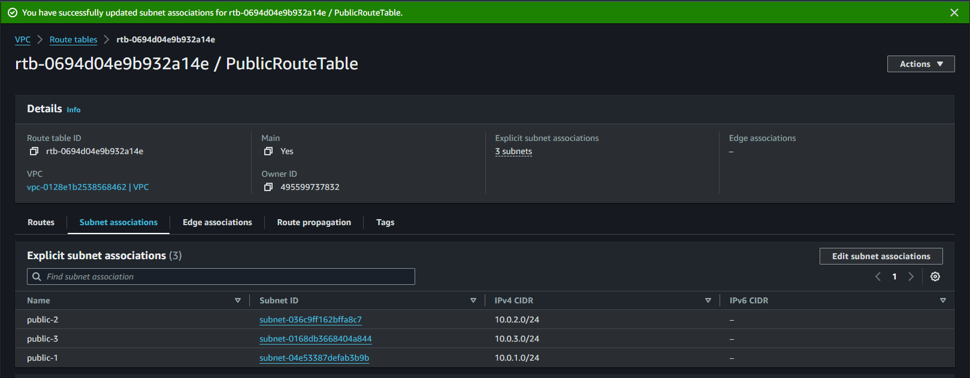

**7. Associate All 3 Public Subnets with Public Route Table**

* aws ec2 associate-route-table --subnet-id subnet-0f87094b2a471498c --route-table-id rtb-0b66860b07c25b329 --region us-west-2
* aws ec2 associate-route-table --subnet-id subnet-0bd22ed69d9d880b2 --route-table-id rtb-0b66860b07c25b329 --region us-west-2
* aws ec2 associate-route-table --subnet-id subnet-01c673dedcc0d5873 --route-table-id rtb-0b66860b07c25b329 --region us-west-2

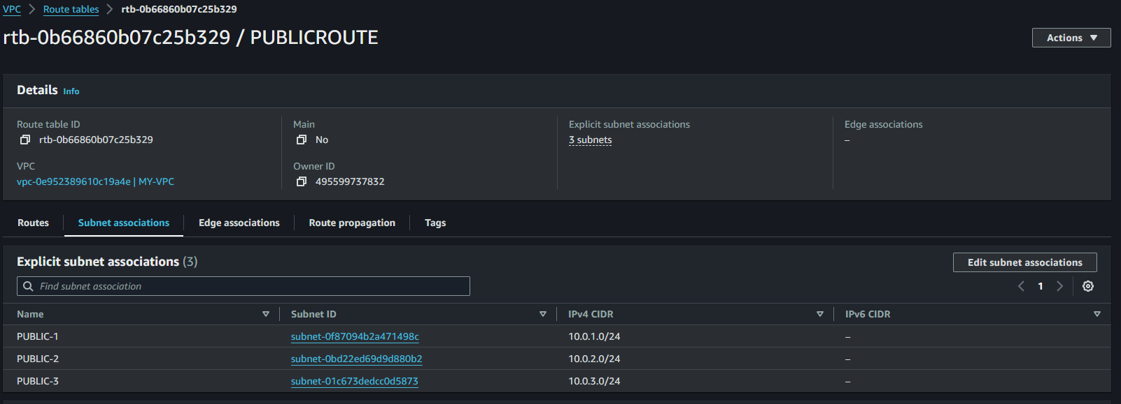

**8. Create a NAT Gateway (NGW) with an Elastic IP**

**Using AWS Management Console:**

* Navigate to NAT Gateways.
* Click Create NAT Gateway.
* Select a public subnet and allocate a new Elastic IP.
* Click Create NAT Gateway.

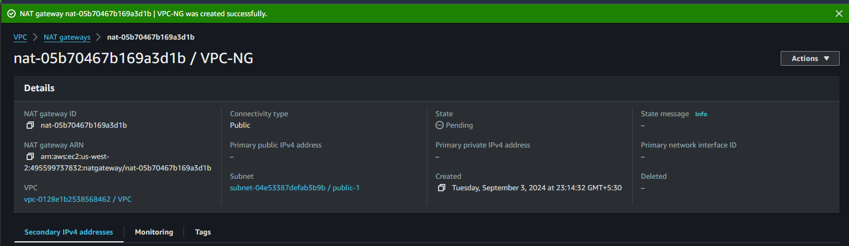

**8. Create a NAT Gateway (NGW) with an Elastic IP**

* aws ec2 allocate-address --domain vpc --region us-west-2
* aws ec2 create-nat-gateway --subnet-id subnet-0f87094b2a471498c --allocation-id eipalloc-0bd2b9ce693590809 --region us-west-2

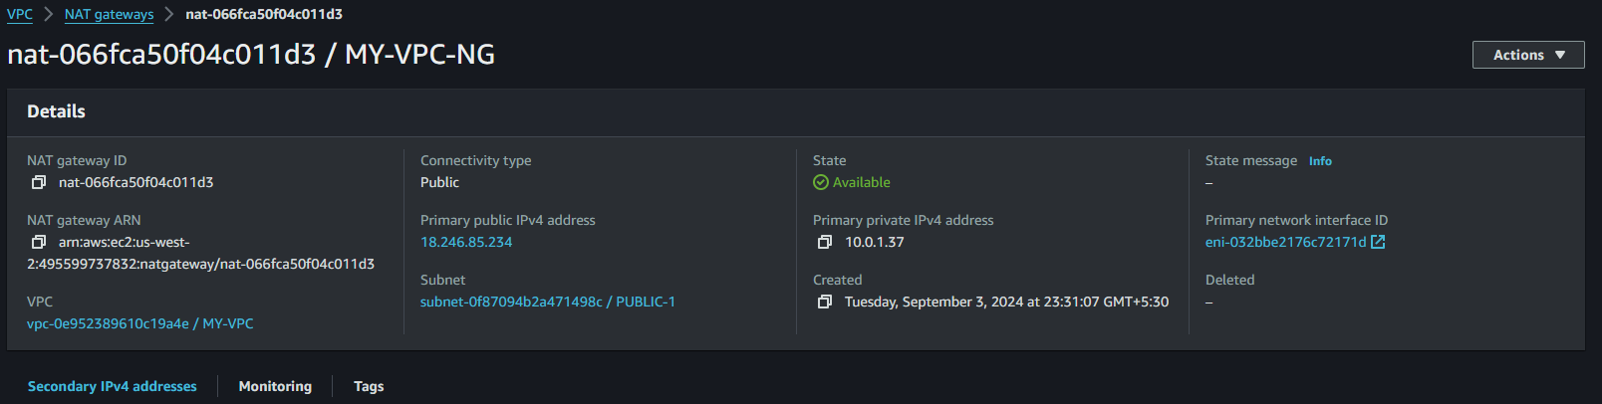

**9. Add a Route to Private Route Table to Send Traffic via NGW**

**Using AWS Management Console:**

* Select the Private Route Table.
* Click Edit Routes and add a route with Destination 0.0.0.0/0 and Target the NAT Gateway.

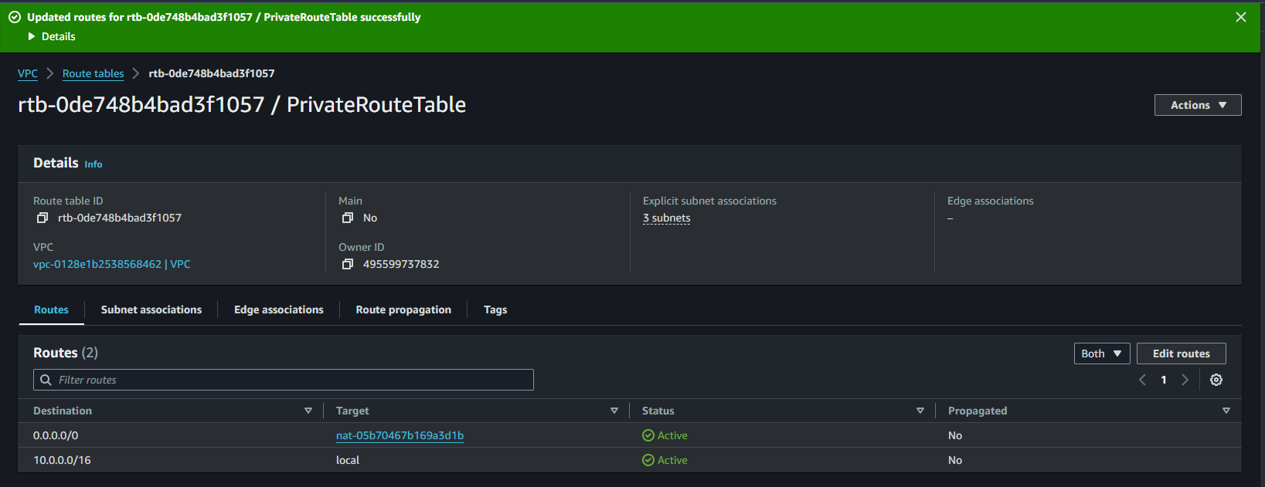

**9. Add a Route to the Private Route Table to Send Traffic via NGW**

* aws ec2 create-route --route-table-id rtb-0c2dd8382830b9f81 --destination-cidr-block 0.0.0.0/0 --nat-gateway-id nat-066fca50f04c011d3 --region us-west-2

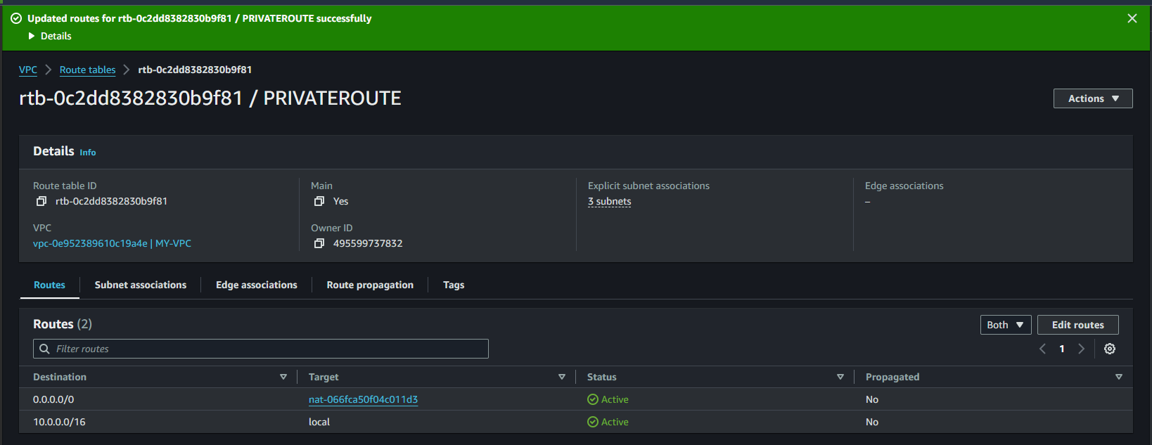

**10. Associate All 3 Private Subnets to the Private Route Table**

**Using AWS Management Console:**

* Go to the Subnets tab in your Private Route Table.
* Click Edit Subnet Associations.
* Select all 3 private subnets and save.

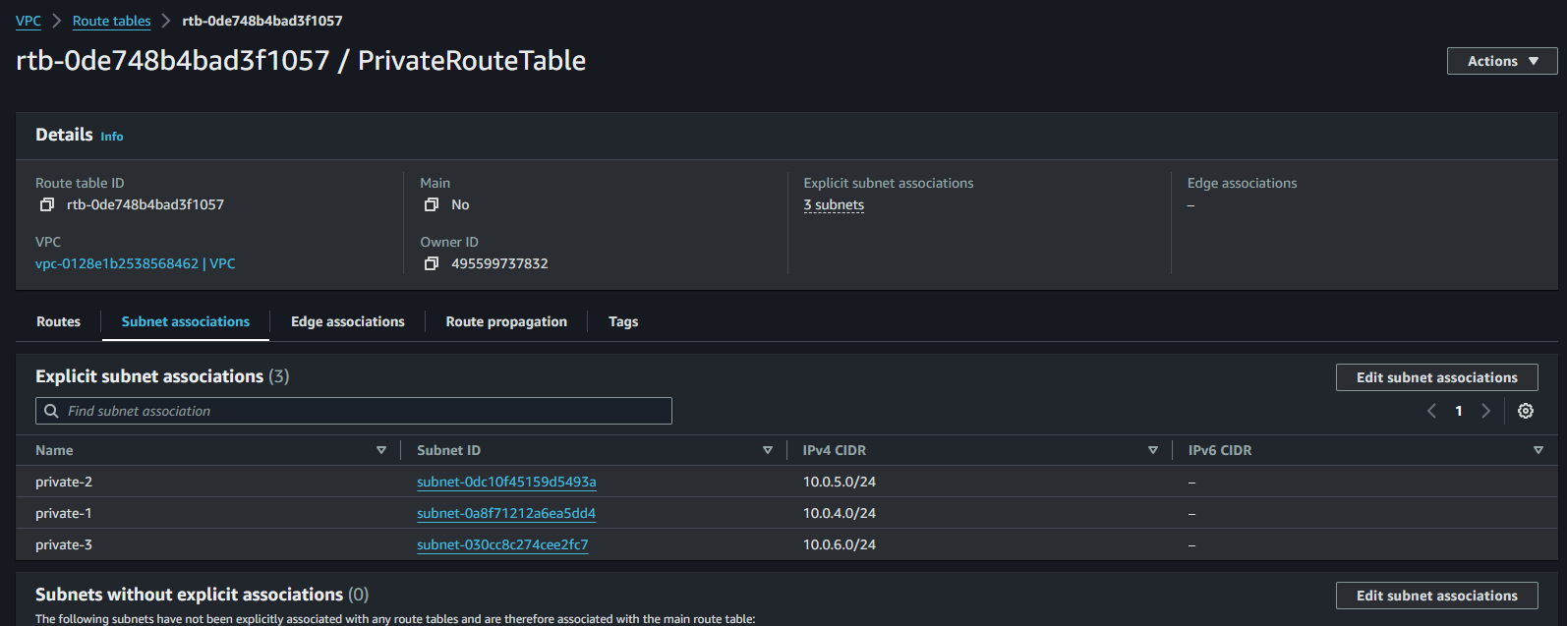

**10. Associate All 3 Private Subnets with the Private Route Table**

* aws ec2 associate-route-table --subnet-id subnet-00d631d1f8593dc81 --route-table-id rtb-0c2dd8382830b9f81 --region us-west-2
* aws ec2 associate-route-table --subnet-id subnet-04ac05286528d3198 --route-table-id rtb-0c2dd8382830b9f81 --region us-west-2
* aws ec2 associate-route-table --subnet-id subnet-023856aee9f4e7353 --route-table-id rtb-0c2dd8382830b9f81 --region us-west-2

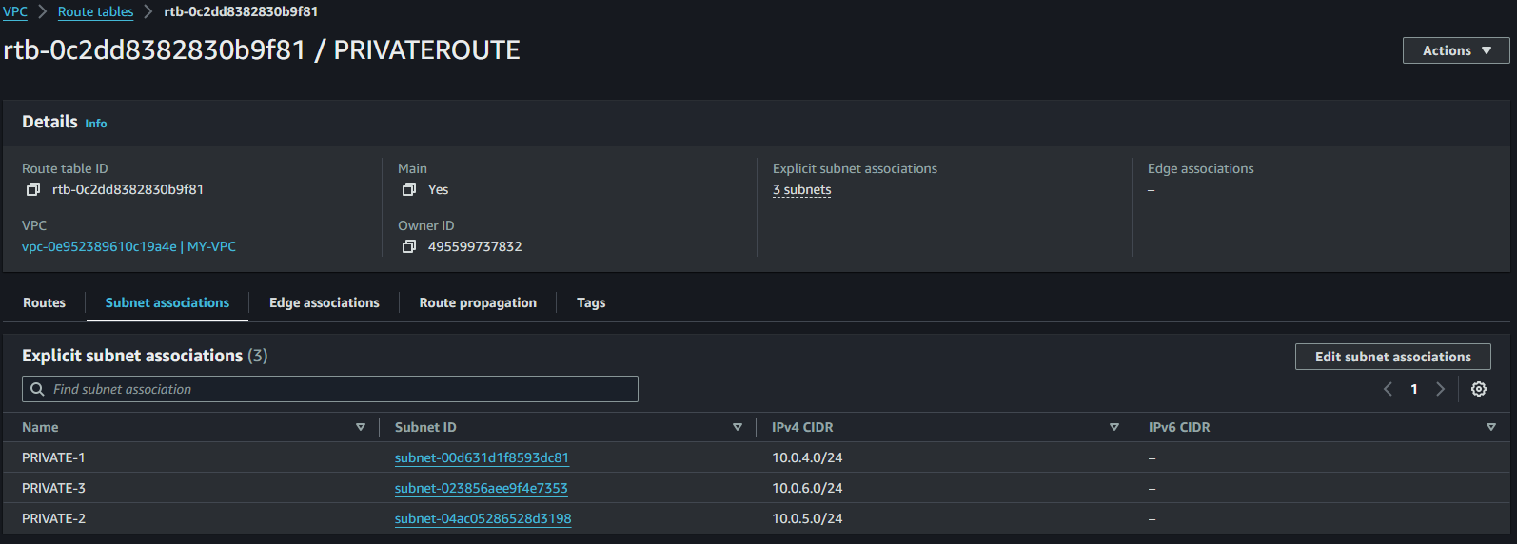

**11. Launch an EC2 Instance in the Public Subnet**

**Using AWS Management Console:**

* Navigate to EC2 Dashboard.
* Click Launch Instance.
* Choose an AMI, instance type, and key pair.
* Under Network, select your VPC and a public subnet.
* Click Launch.

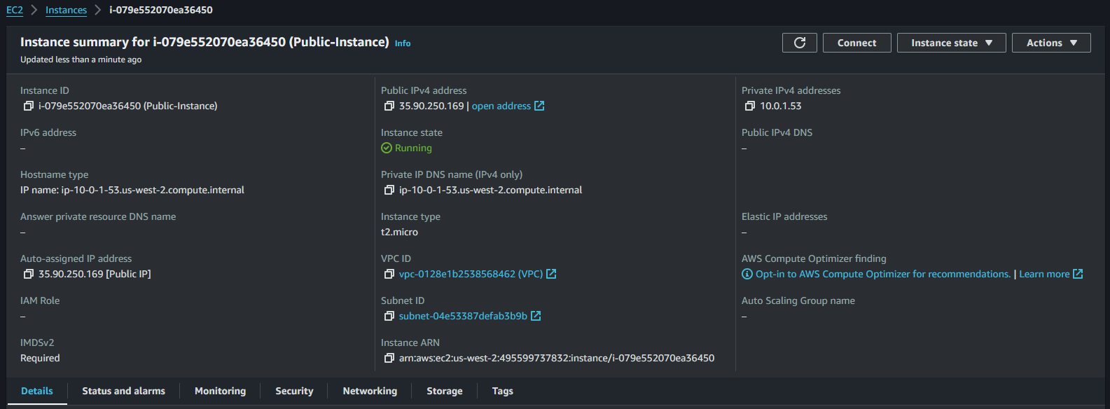

**11. Launch an EC2 Instance in a Public Subnet**

* aws ec2 run-instances --image-id ami-05134c8ef96964280 --instance-type t2.micro --subnet-id subnet-0f87094b2a471498c --associate-public-ip-address --key-name pradeep --region us-west-2

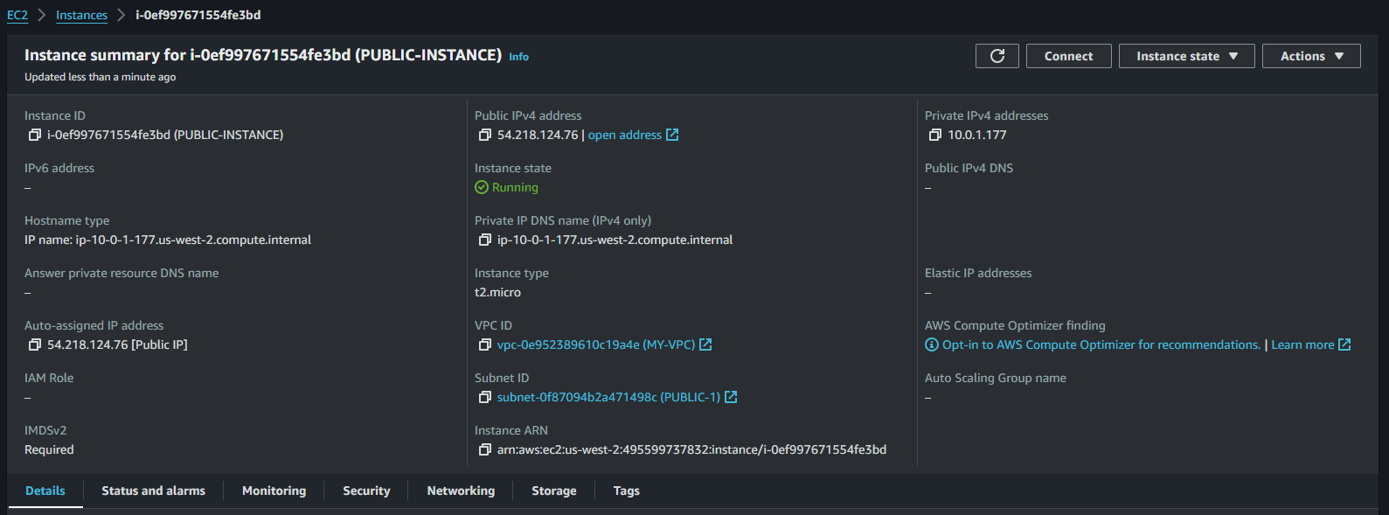

**12. Launch an EC2 Instance in the Private Subnet**

**Using AWS Management Console:**

* Navigate to EC2 Dashboard.
* Click Launch Instance.
* Choose an AMI, instance type, and key pair.
* Under Network, select your VPC and a private subnet.
* Click Launch.

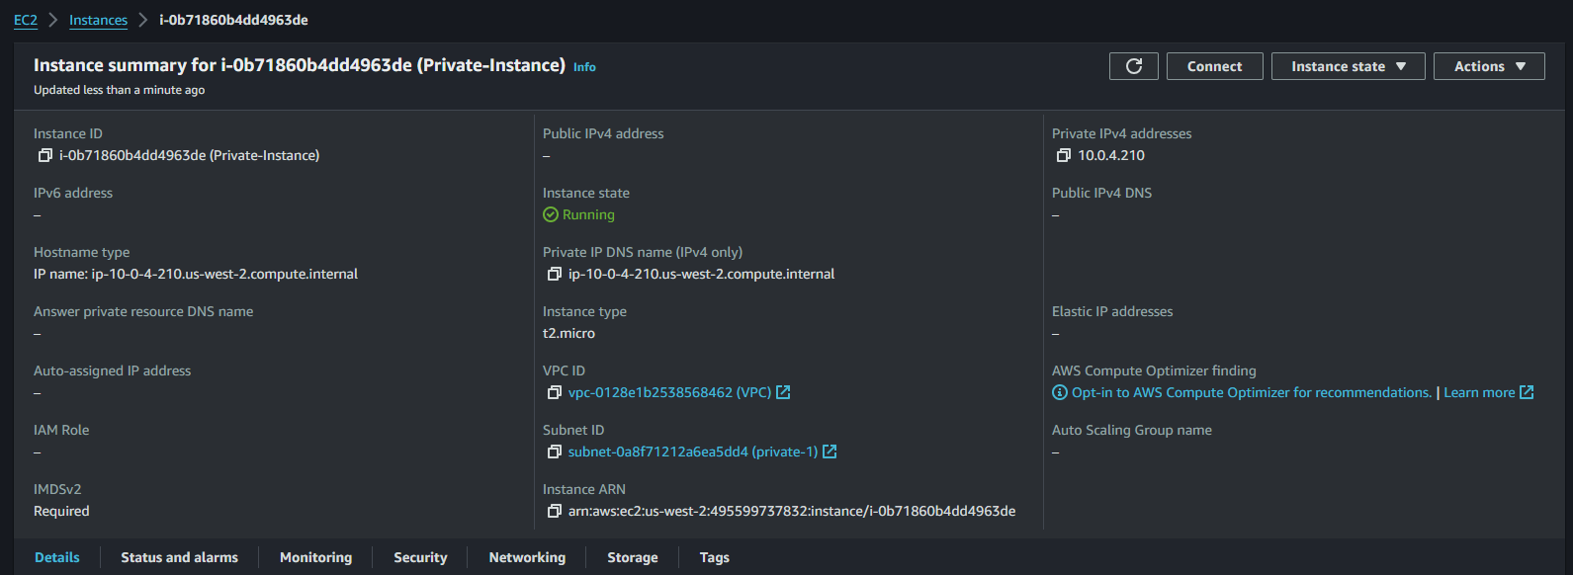

**12. Launch an EC2 Instance in a Private Subnet**

* aws ec2 run-instances --image-id ami-05134c8ef96964280 --instance-type t2.micro --subnet-id subnet-00d631d1f8593dc81 --associate-public-ip-address --key-name pradeep --region us-west-2

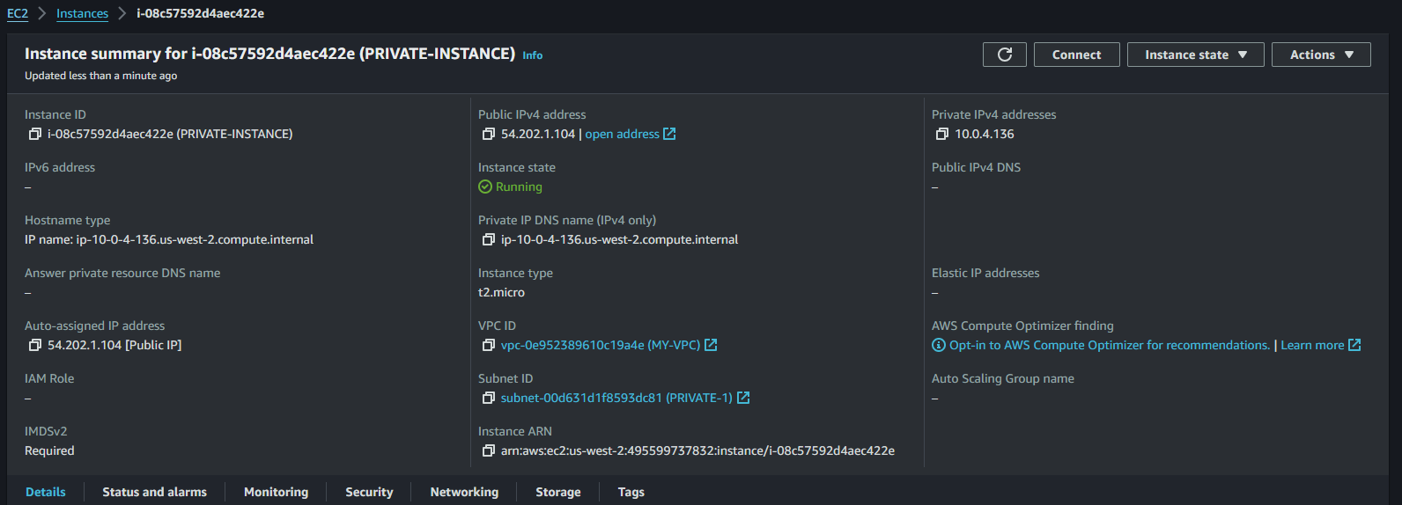

**13. Connect to EC2 Instance in the Public Subnet**

**Using AWS Management Console:**

1. Select your Public EC2 Instance.
2. Click Connect and follow the instructions using SSH.

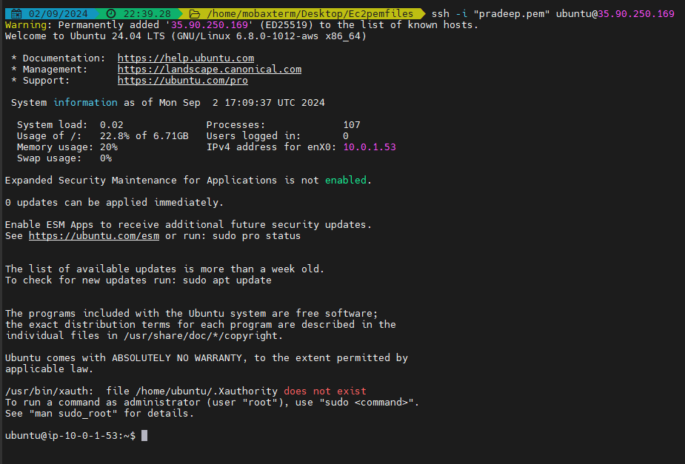

**14. Connect to EC2 Instance in the Private Subnet via Public Instance**

* SSH into the Public Instance as described in Task 13.
* From the public instance, connect to the Private Instance using its private IP.

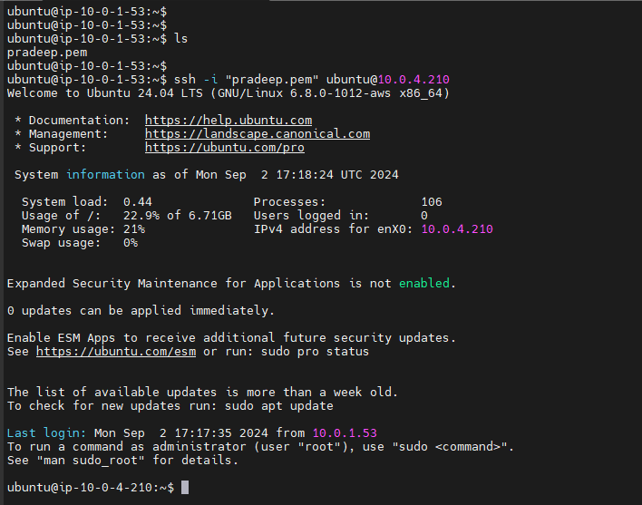

**15. Stop Both EC2 Instances**

**Using AWS Management Console:**

* Select both instances.
* Click Actions > Instance State > Stop.

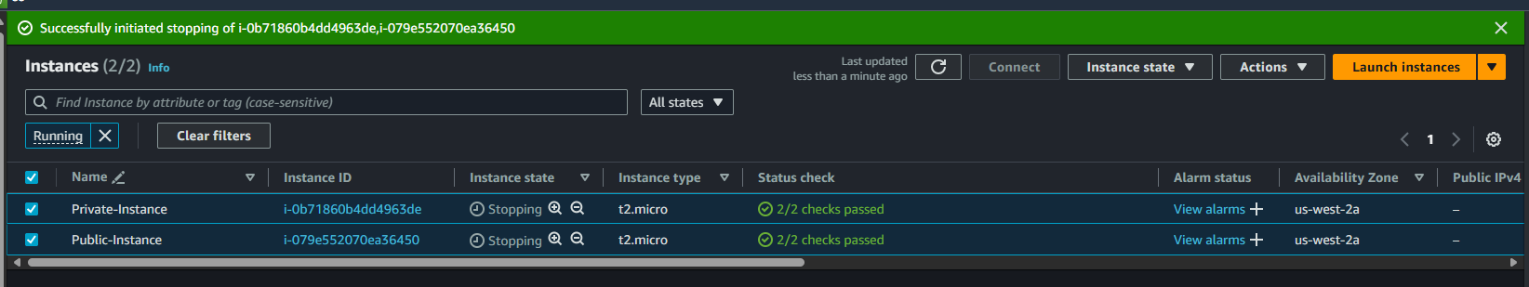

**16. Create an EC2 Instance with 8 GB Storage**

**Using AWS Management Console:**

* Launch a new EC2 instance as in Task 11.
* Under Storage, set the EBS volume to 8 GB.

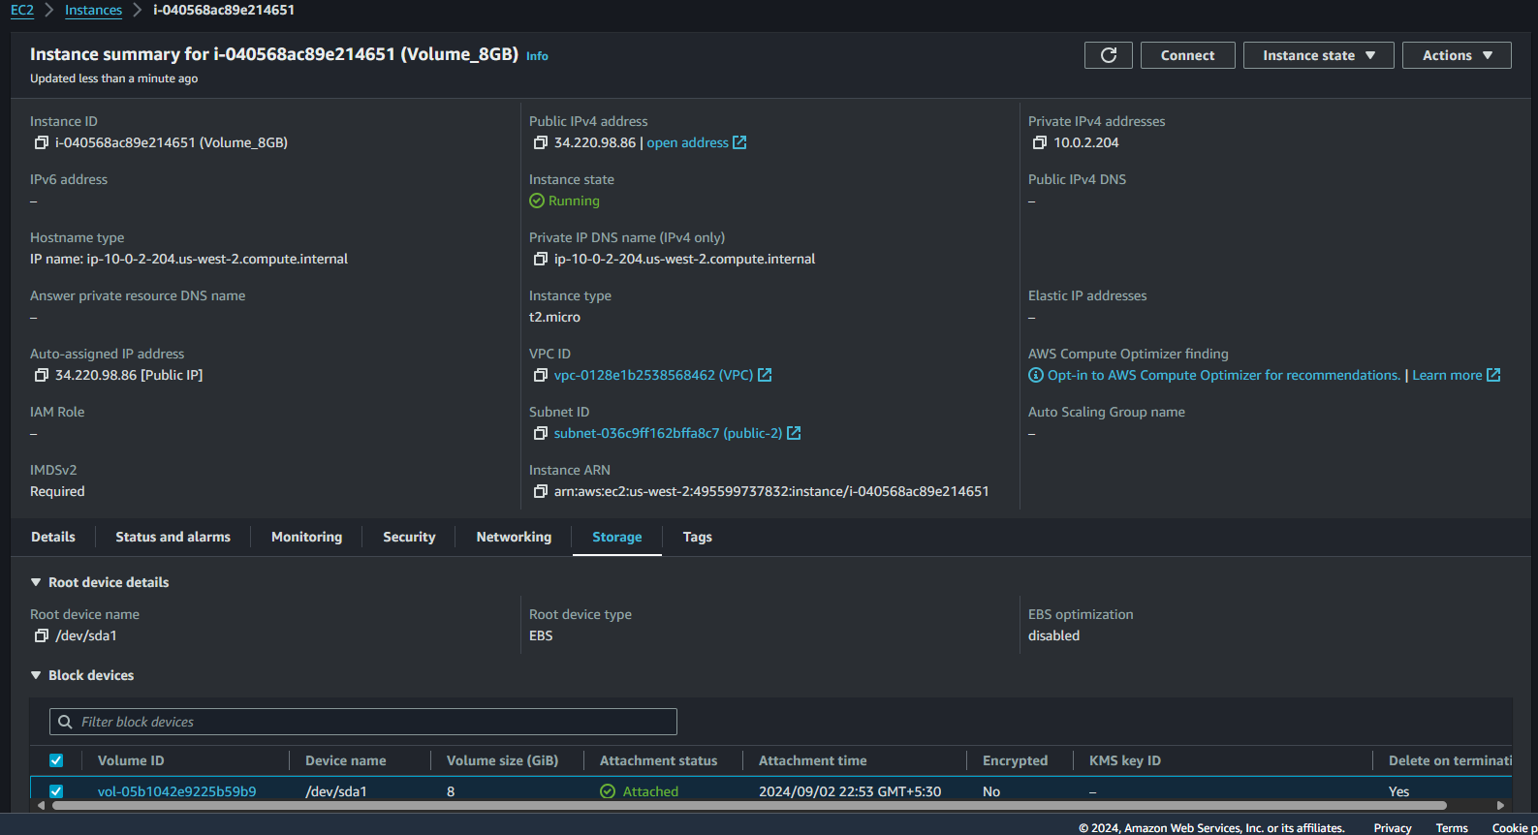

**16. Create an EC2 Instance with 8 GB Storage**

* aws ec2 run-instances \

--image-id ami-05134c8ef96964280 \

--instance-type t2.micro \

--block-device-mappings DeviceName=/dev/xvda,Ebs={VolumeSize=8} \

--key-name pradeep \

--region us-west-2 \

--subnet-id subnet-00d631d1f8593dc81

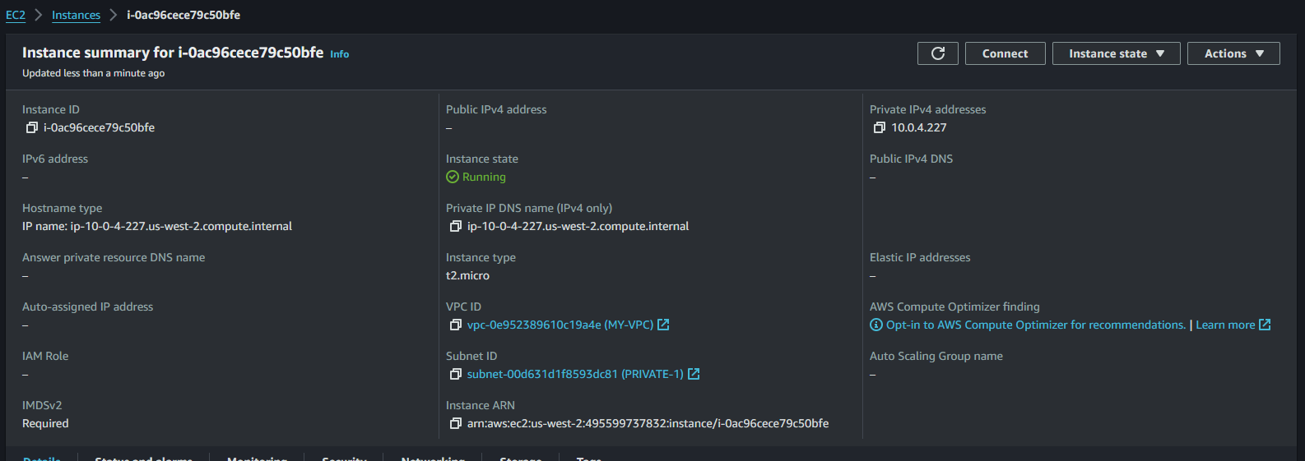

**17. Create a Snapshot for the EC2 Instance's EBS Volume**

**Using AWS Management Console:**

* Select the EBS Volume from the Volumes section.
* Click Actions > Create Snapshot.

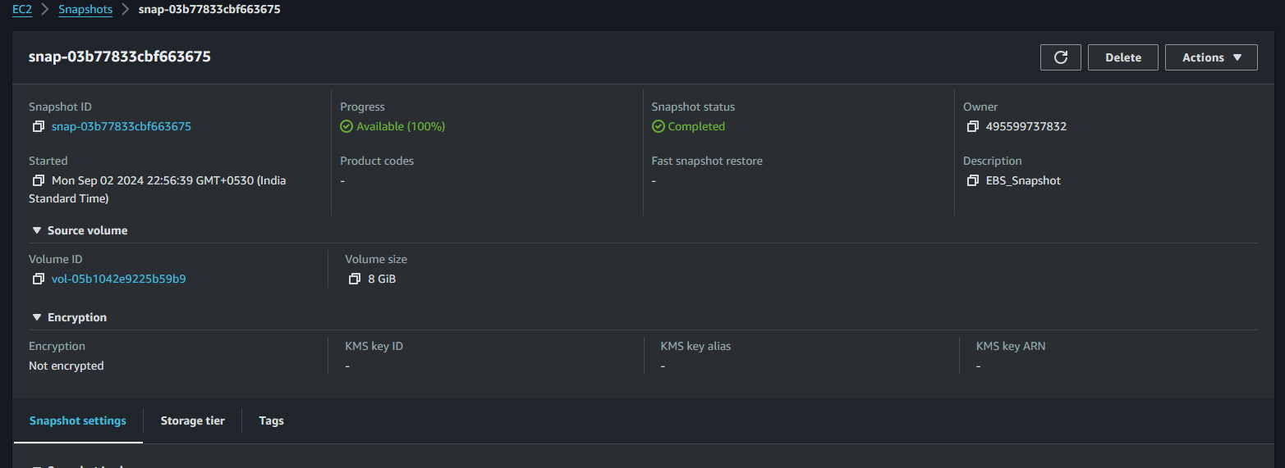

**17. Create a Snapshot for the EC2 Instance's EBS Volume**

* aws ec2 create-snapshot --volume-id vol-0ff4ff9ea1dd7286d --description "Snapshot of EBS volume" --region us-west-2

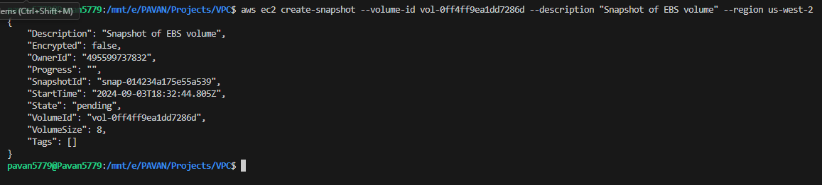

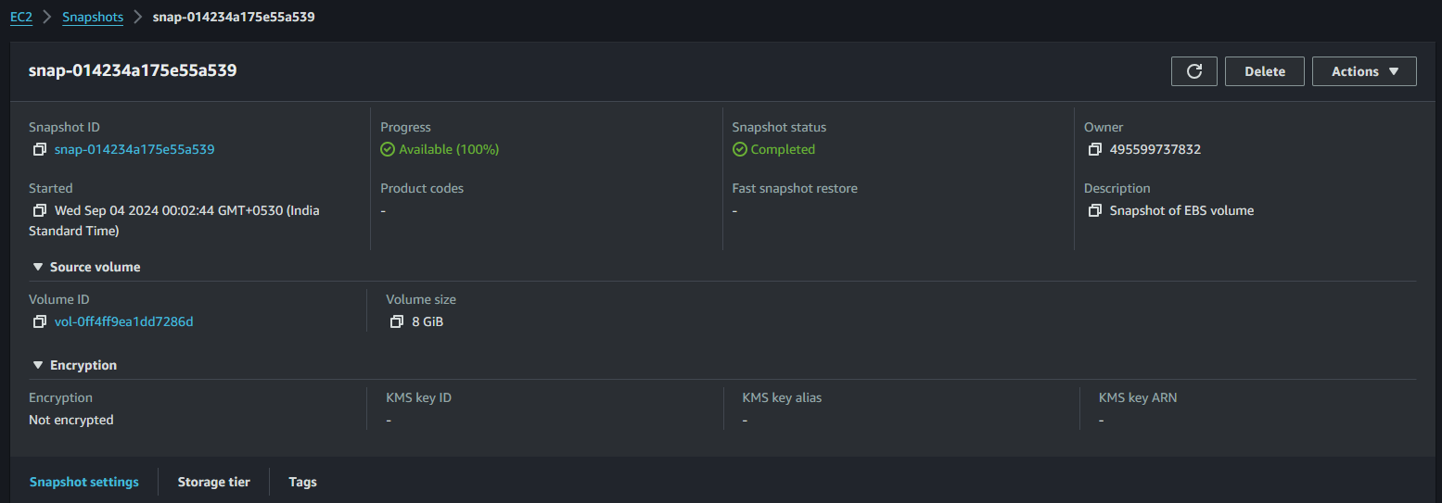

**18. Extend Storage by an Additional 8 GB for the Running Instance**

**Using AWS Management Console:**

* Stop the instance.
* Select the Volume, click Modify Volume, and increase the size by 8 GB.
* Start the instance and resize the filesystem within the instance

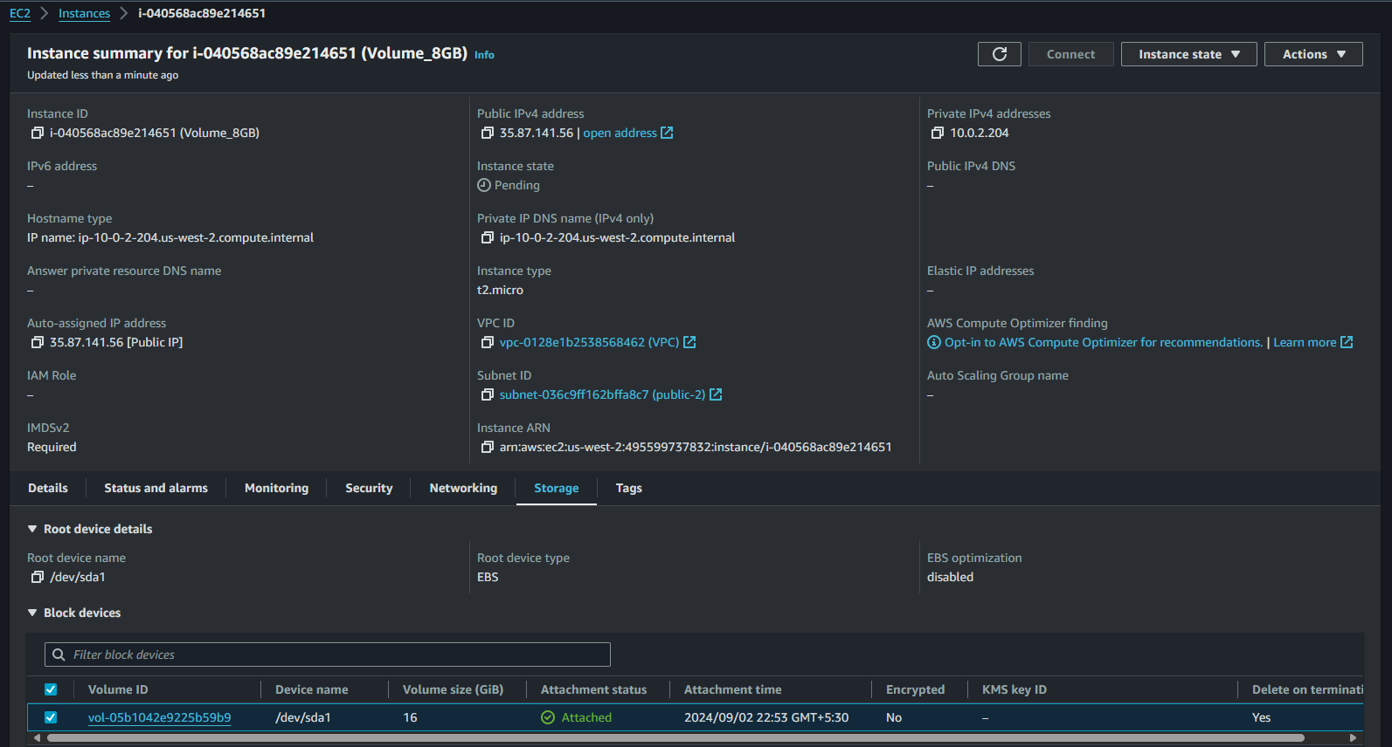

**18. Extend Storage by an Additional 8 GB for the Running Instance**

* aws ec2 modify-volume --volume-id vol-0ff4ff9ea1dd7286d --size 16 --region us-west-2

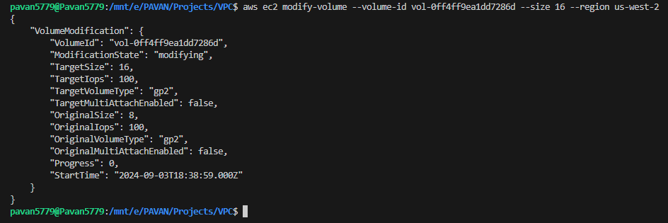

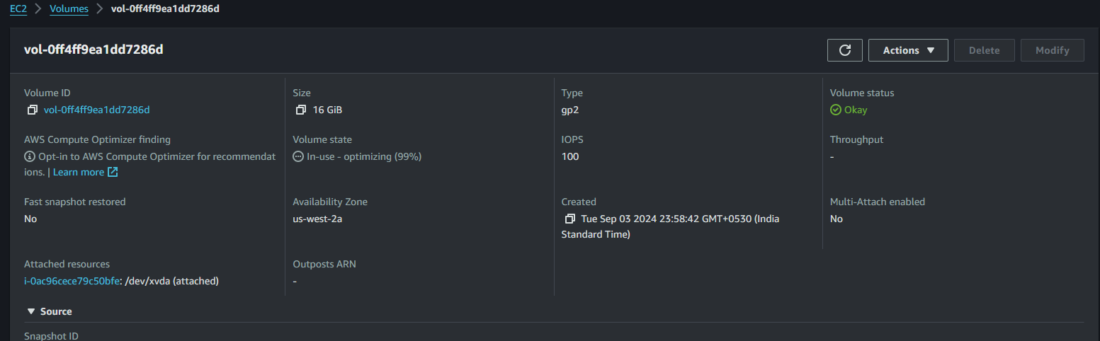

**19. Delete the Snapshot Created Earlier**

**Using AWS Management Console:**

* Go to Snapshots.
* Select the snapshot and click Delete.

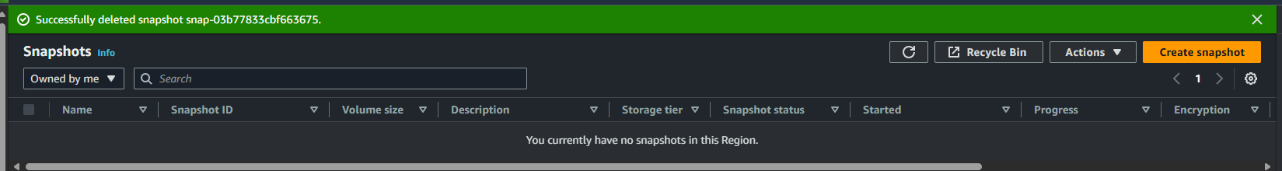

**19. Delete the Snapshot Created Earlier**



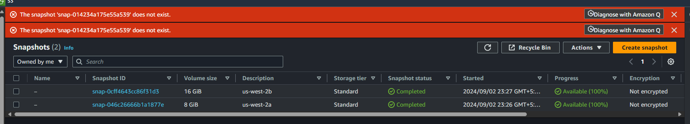

**20. Instructions on How to Connect to an EC2 Instance if the PEM Key is Lost**

* Stop the Instance.
* Detach the Root EBS Volume.
* Attach the EBS Volume to a Different EC2 Instance.
* Access the Volume via SSH on the new instance.
* Modify the SSH Configuration: Inject a new SSH key or allow password authentication.
* Detach and Reattach the Volume to the original instance.
* Start the Original Instance and connect using the new credentials.

**20. Instructions on How to Connect to an EC2 Instance if the PEM Key is Lost**

Explanation: If the PEM key is lost, the typical approach is to:

1. Create a new key pair.
2. Stop the instance.
3. Detach the root EBS volume and attach it to another instance.
4. Mount the volume and replace the ~/.ssh/authorized_keys file with the new public key.
5. Reattach the volume to the original instance and start it.

**21. Create Instance-1 in us-west-2a with an 8 GB Volume**

**Using AWS Management Console:**

* Launch an EC2 instance, selecting us-west-2a and an 8 GB volume.

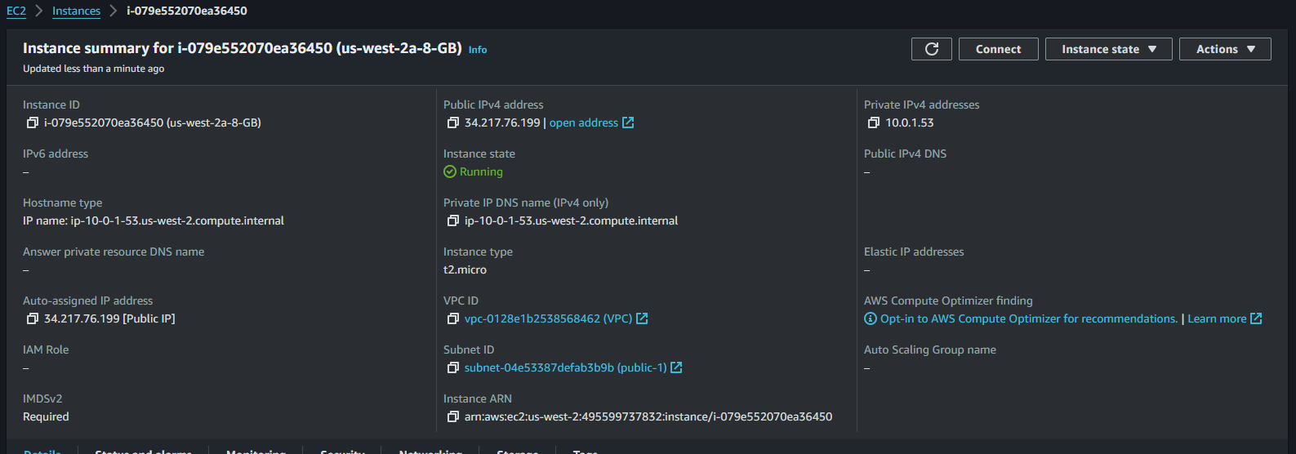

**21. Create Instance-1 in us-west-2a with an 8 GB Volume**

* aws ec2 run-instances \

--image-id ami-05134c8ef96964280 \

--instance-type t2.micro \

--block-device-mappings DeviceName=/dev/xvda,Ebs={VolumeSize=8} \

--key-name pradeep \

--subnet-id subnet-00d631d1f8593dc81 \

--region us-west-2

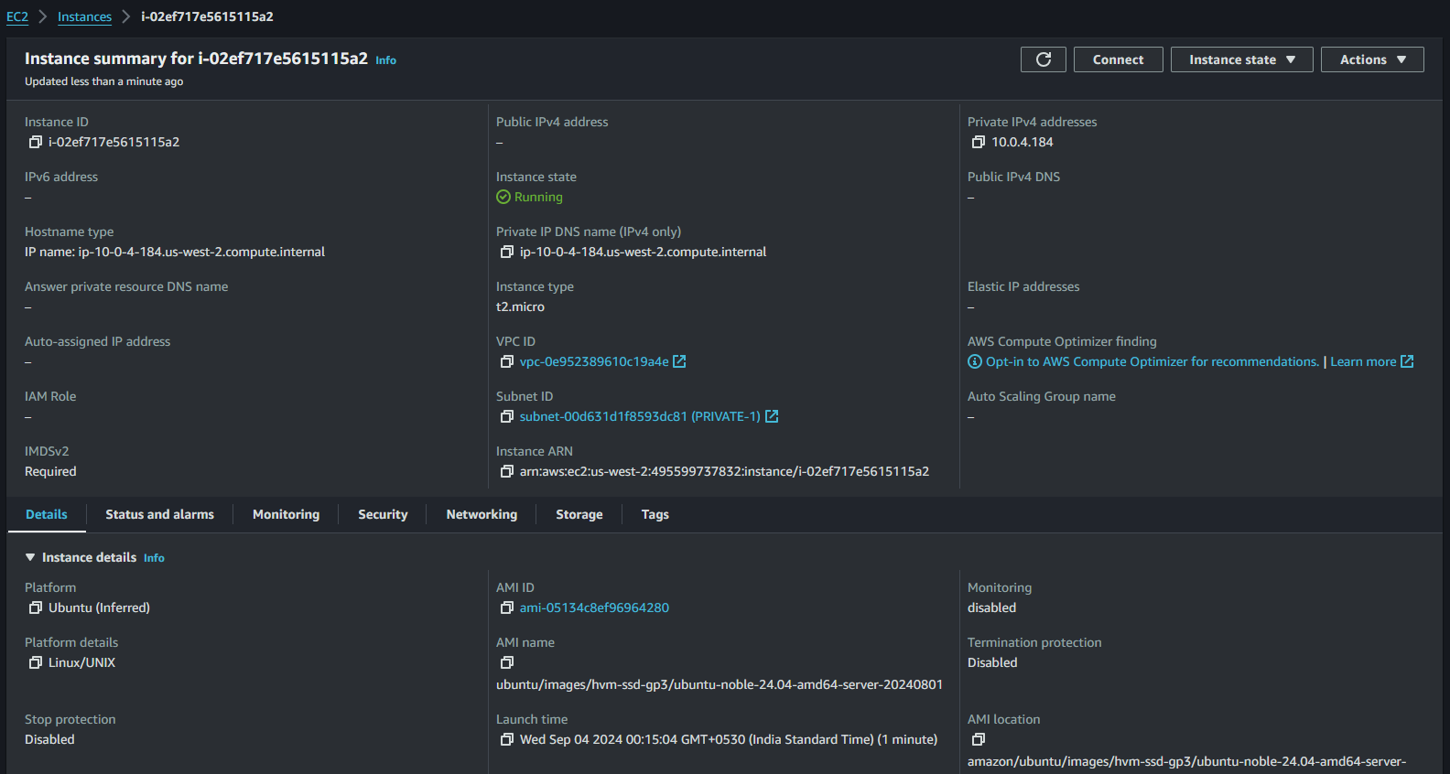

**22. Create Instance-2 in us-west-2b with an 8 GB Volume**

**Using AWS Management Console:**

* Launch an EC2 instance, selecting us-west-2b and an 8 GB volume.

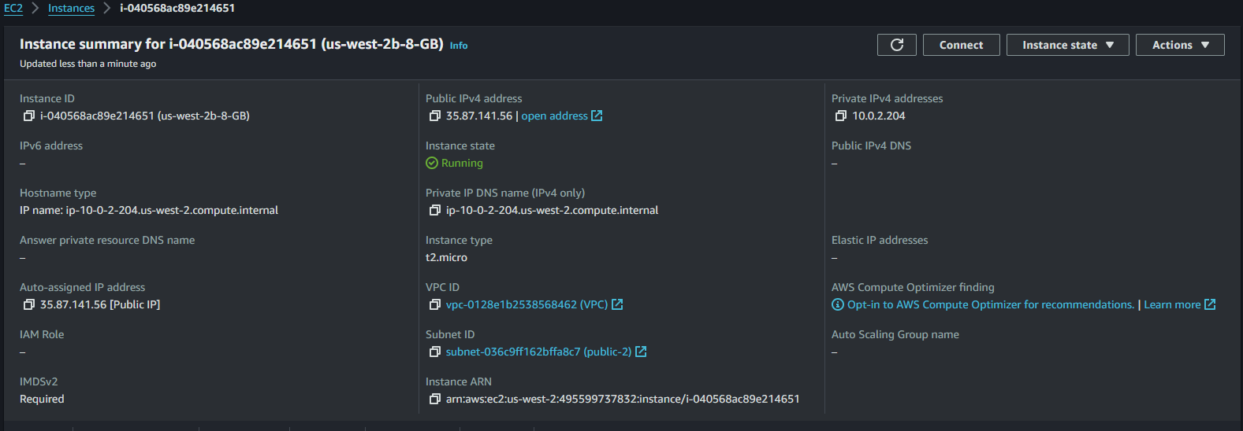

**22. Create Instance-2 in us-west-2b with an 8 GB Volume**

* aws ec2 run-instances \

--image-id ami-05134c8ef96964280 \

--instance-type t2.micro \

--block-device-mappings DeviceName=/dev/xvda,Ebs={VolumeSize=8} \

--key-name pradeep \

--subnet-id subnet-0bd22ed69d9d880b2 \

--region us-west-2

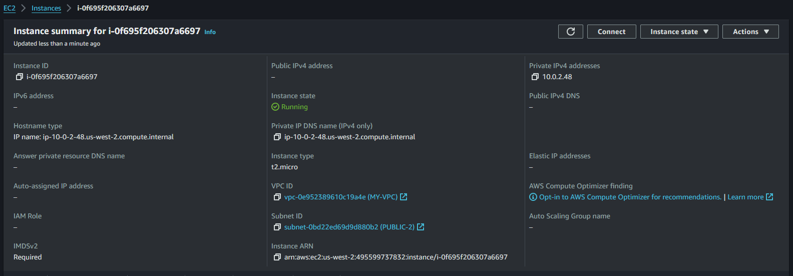

**23. Stop and Detach the EBS Volume from us-west-2a and attach it to us-west-2b**

**Using AWS Management Console:**

* Stop us-west-2a.
* Detach the EBS Volume from us-west-2a.
* Attach the EBS Volume to us-west-2b.

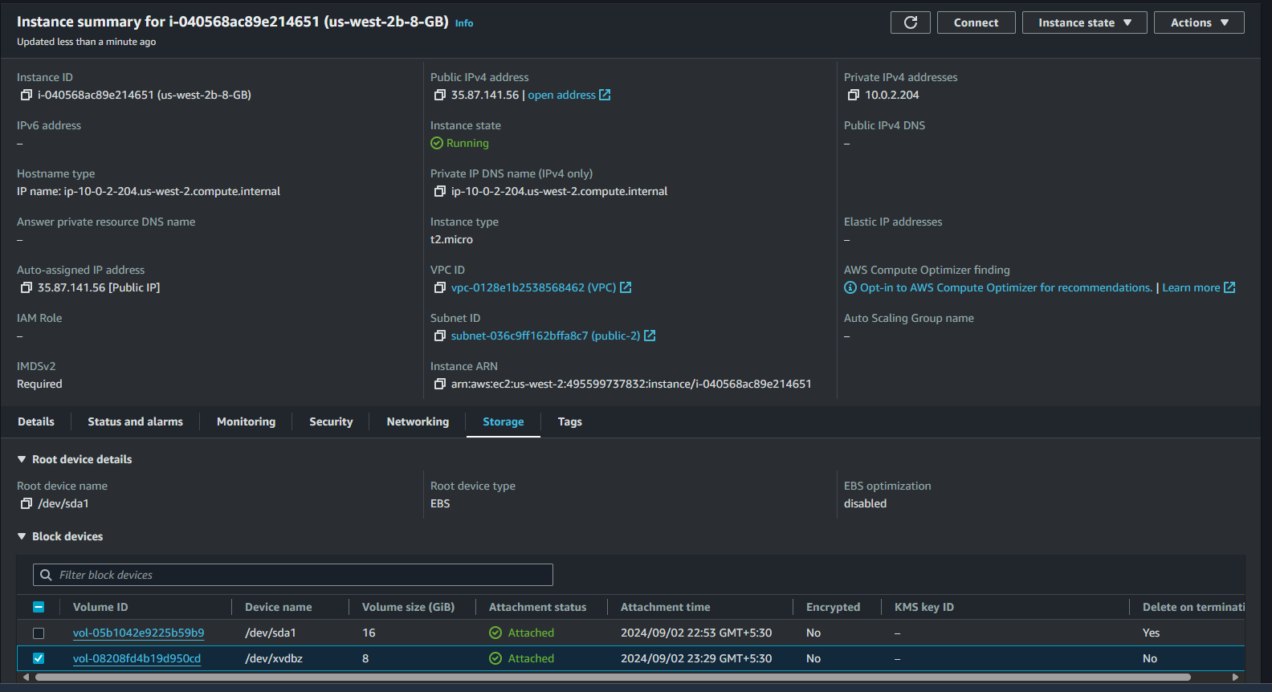

**23. Stop and Detach the EBS Volume from us-west-2a and attach it to us-west-2b**

* aws ec2 detach-volume --volume-id vol-0ffaf7e9abe58d473 --region us-west-2
* aws ec2 create-snapshot --volume-id vol-0410e921a44d4d988 --description "Snapshot of volume in wrong AZ" --region us-west-2
* aws ec2 create-volume --snapshot-id snap-01f345ef9311be0ca --availability-zone us-west-2b --region us-west-2
* aws ec2 attach-volume --volume-id vol-0e998e346975f68a7 --instance-id i-0f695f206307a6697 --device /dev/sdf --region us-west-2

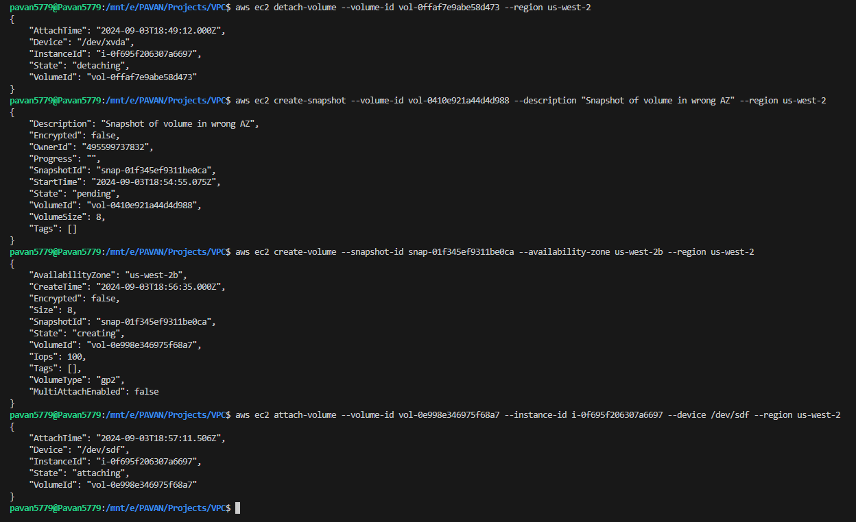

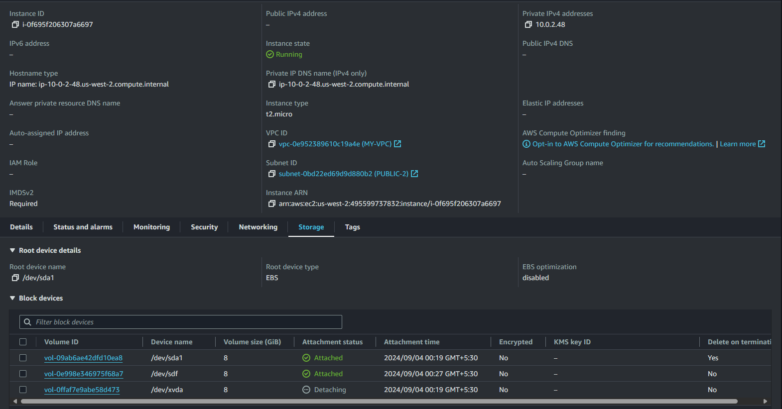

**SCRIPT-1**

Using AWS Management Console (UI)

1. Retrieve a List of Instances:
   * In the left-hand menu, select Instances under the Instances section.
   * You will see a list of all running instances in the selected region.
2. Filter Instances by Name:
   * Use the Search/Filter bar at the top of the list.
   * Filter instances by entering a part of the instance name or the full name.
3. Stop the Matching Instances:
   * Select the instances that match your filter.
   * Click the Actions button, then select Instance State > Stop Instance.
   * Confirm the action by clicking Stop.

**USING AWS CLI**

* aws ec2 describe-instances --region us-west-2 --query "Reservations[*].Instances[*].[InstanceId,Tags[?Key=='Name'].Value]" --output text

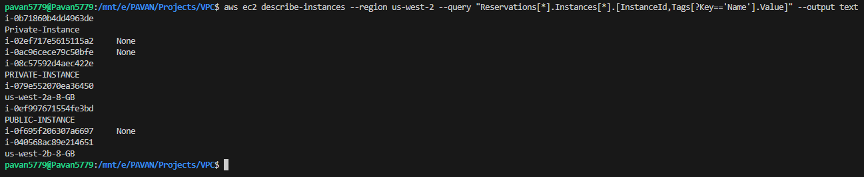

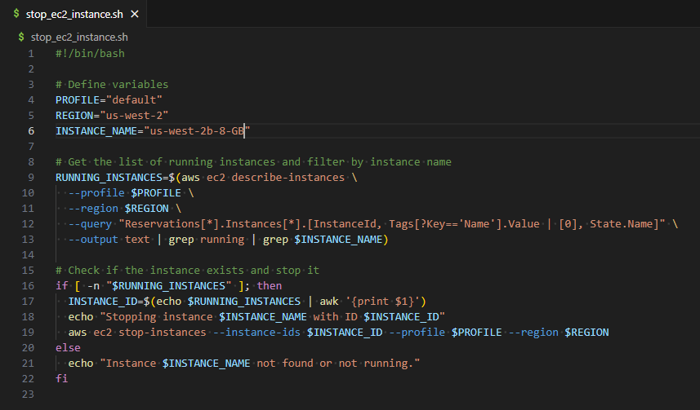

**Use commands**

* Chmod +x stop_ec2_instance.sh
* ./stop_ec2_instance.sh

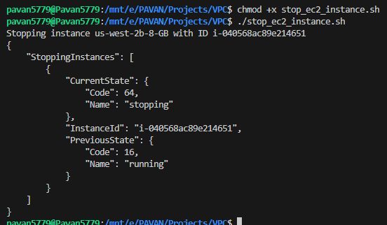

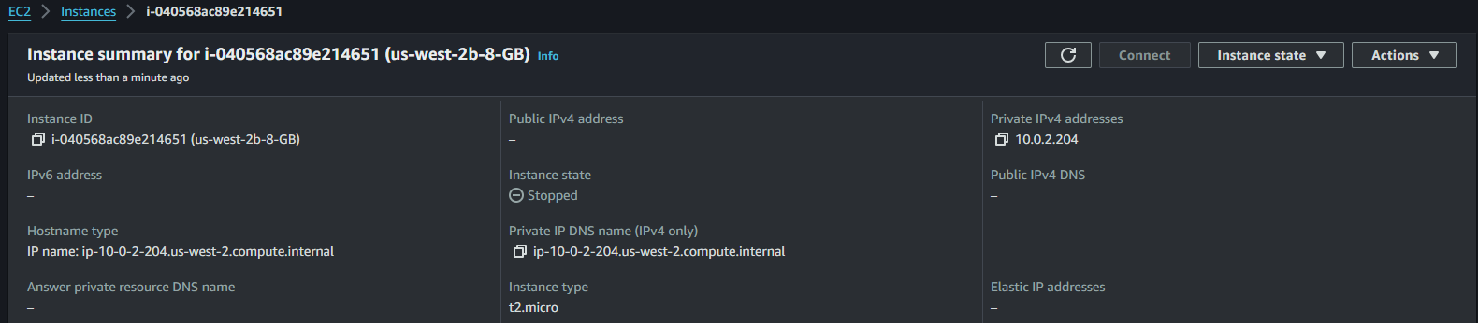

**SCRIPT-2**

**Create an SNS Topic**

In the SNS console, create a topic to notify if any issues occur during the instance start or stop operations.

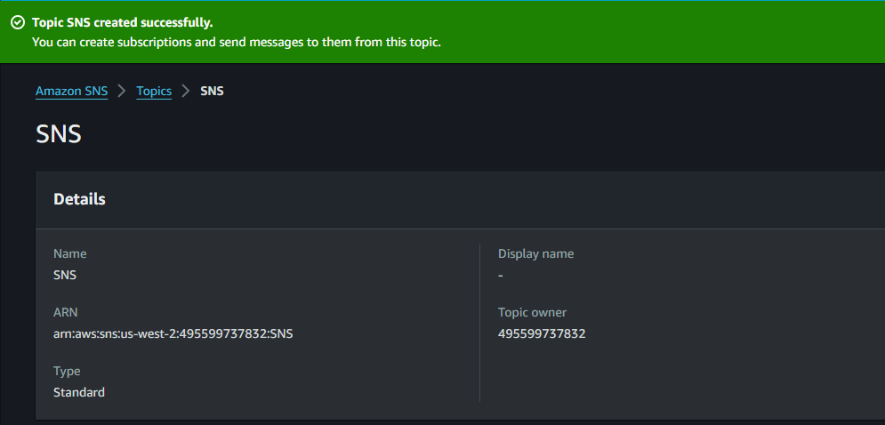

**Create an IAM Policy**

* Define an IAM policy named stopandstartinstance with permissions for EC2 actions (ec2:StartInstances, ec2:StopInstances, ec2:DescribeInstances).

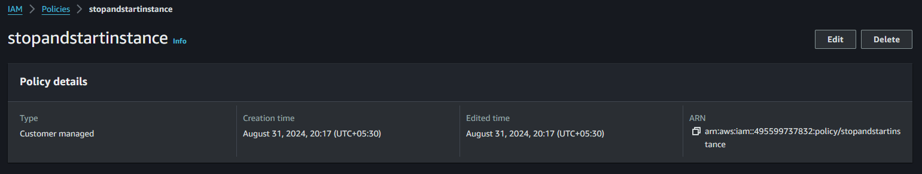

**Create a Lambda Role**

* In IAM, create a Lambda execution role.
* Attach the stopandstartinstance policy to this role.

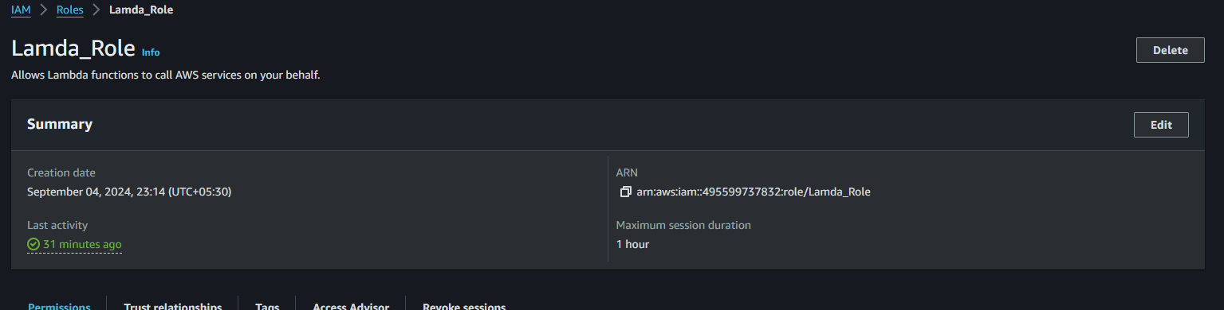

**Create Lambda Functions**

**Stop Function:**

* Go to the AWS Lambda console, create a new Lambda function named stopInstances.

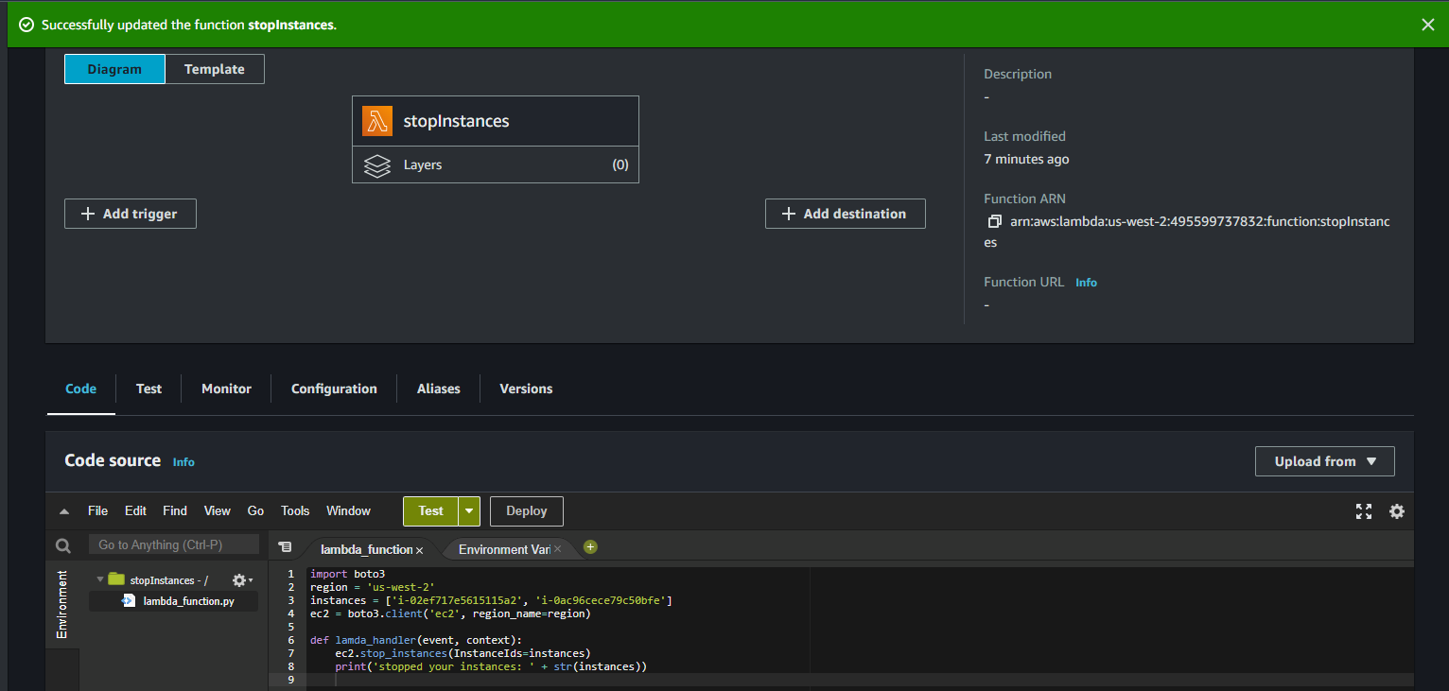

**Start Function:**

* Create another Lambda function named startInstances.

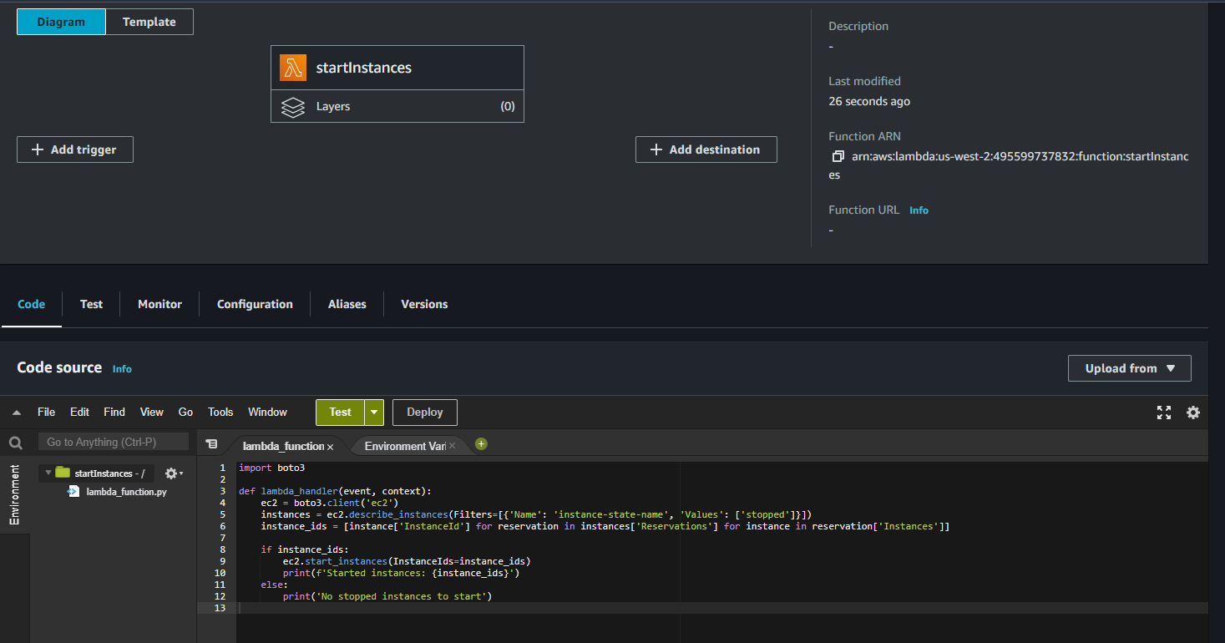

**Create CloudWatch Rules**

**Stop Rule:**

Go to the CloudWatch console and create a rule with a cron expression to trigger the stopInstances Lambda function at 00:35 AM.

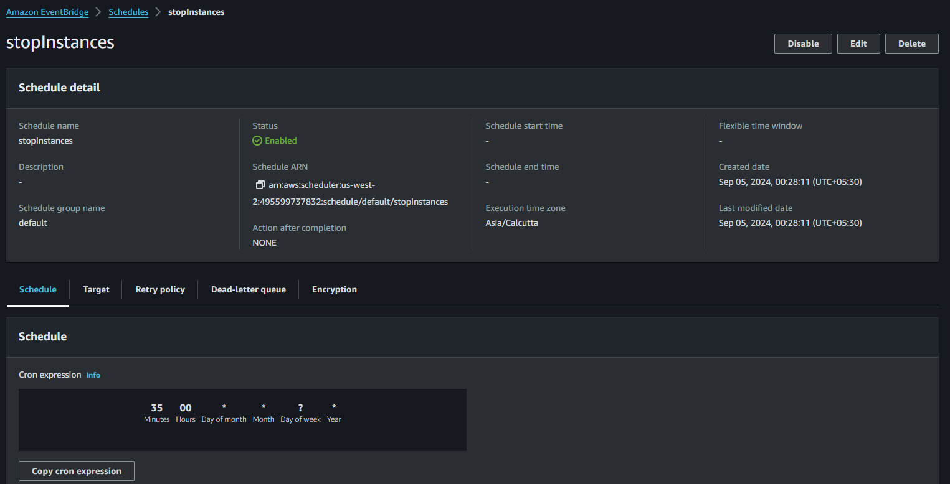

**Start Rule:**

Create another rule with a cron expression to trigger the startInstances Lambda function at 10:30 AM.

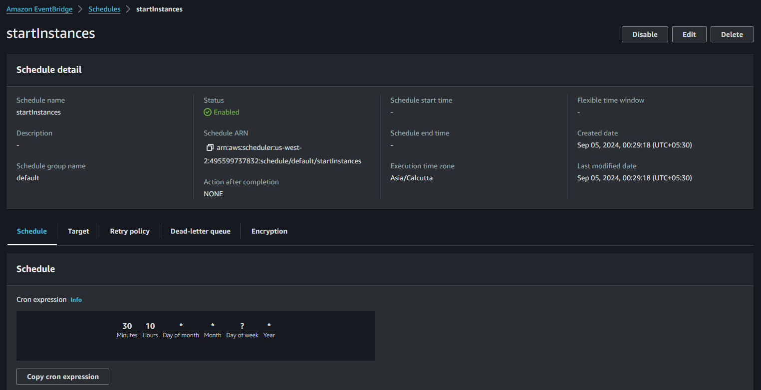

**Task 24: Retrieve the List of Private IP Addresses of Running Instances**

**Step 1: Start Two EC2 Instances Using AWS Management Console**

1. **Launch an EC2 Instance:**
   * Click on "Launch Instance."
   * Choose an AMI (Amazon Machine Image):
     + Select a **Red Hat** image for the first instance.

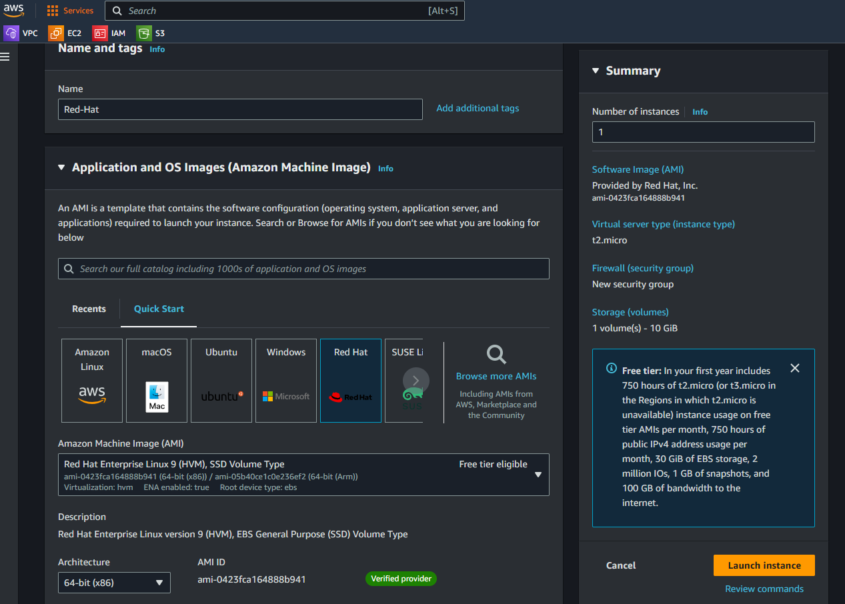

* + - Launch another instance using **Ubuntu** or **CentOS**.
  + Choose the instance type (e.g., t2.micro for free tier).
  + Configure the instance details, add storage, and configure security groups (allow SSH access on port 22).
  + Review and launch the instances.

1. **Get Instance IDs:**
   * After launching, go to the **Instances** section in the EC2 dashboard.
   * Note down the Instance IDs of the two instances you just launched.



**Step 2: Retrieve the Private IP Addresses Using AWS CLI**

1. **Retrieve the Private IP Addresses:**
   * Use the following command to list the running instances and their private IP addresses:

* aws ec2 describe-instances \

--filters "Name=instance-state-name,Values=running" \

--query "Reservations[*].Instances[*].[InstanceId,PrivateIpAddress]" \

--output table

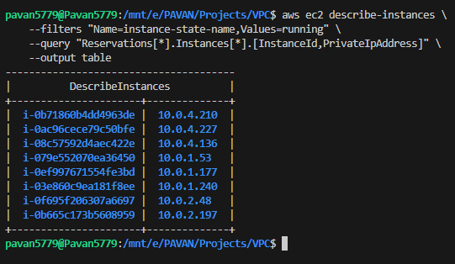

**Task 25: Redirect Output to a Text File and Create a Script to Install Java Packages**

**Step 1: Redirect the Private IP Addresses to a Text File**

1. **Redirect Output to a File:**

* aws ec2 describe-instances --filters "Name=instance-state-name,Values=running" --query "Reservations[*].Instances[*].[InstanceId,PrivateIpAddress]" --output text > instance_ips.txt

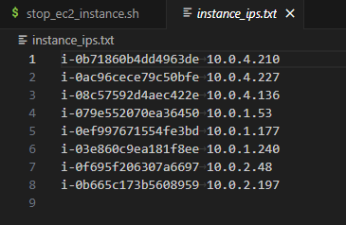

**Step 2: Create a Script to Connect to Each Instance and Install Java**

1. create a bash script install_java.sh

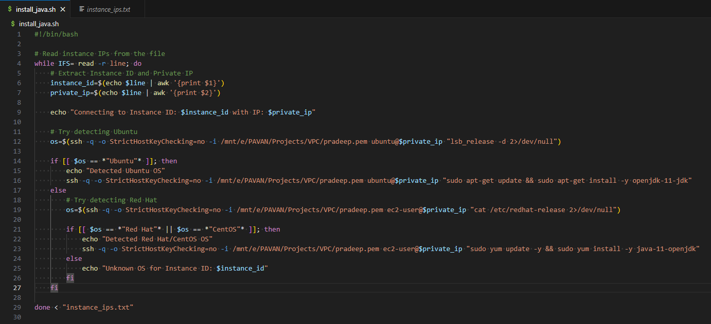

**26. Create Testing Group**

**1. Create a Testing Group**

1. Go to the AWS Management Console.
2. Search for and select IAM (Identity and Access Management).
3. In the left-hand menu, click on Groups.
4. Click Create Group.
5. Name the group Testing.
6. Choose Next and proceed without attaching any policies (we’ll do this later).
7. Click Create Group.

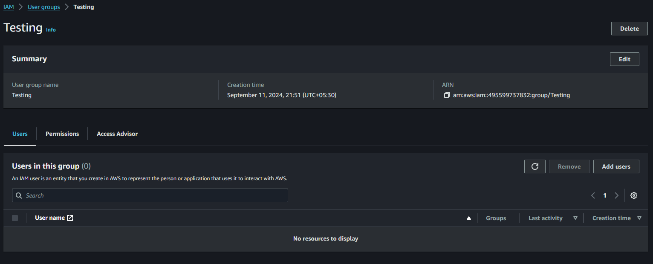

**27. Create User A with Password Change Requirement**

1. In the IAM Console, click Users from the left-hand menu.
2. Click Add User.
3. Name the user Tester-A.
4. Select Programmatic access (if the user needs API/CLI access) and AWS Management Console access.
5. Under Console password, choose Autogenerated password and check the box to require the user to change the password on their first login.
6. Click Next: Permissions.
7. Select Add user to group and choose the Testing group.
8. Click Next: Tags, then Next: Review, and finally Create User.

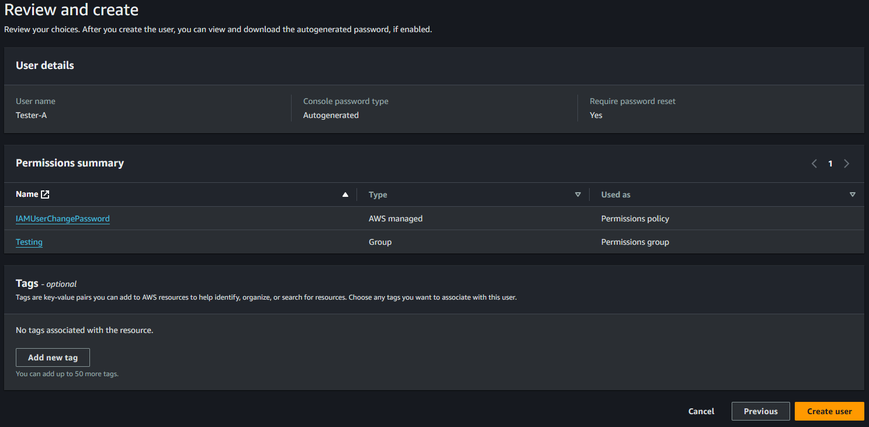

**28. Create a Read-Only S3 Policy for the Developers Group**

1. In the IAM Console, click Policies from the left-hand menu.
2. Click Create Policy.
3. In the JSON tab, paste the following policy:
4. Click Next: Tags, then Next: Review.
5. Name the policy S3ReadOnlyAccess.
6. Click Create Policy.

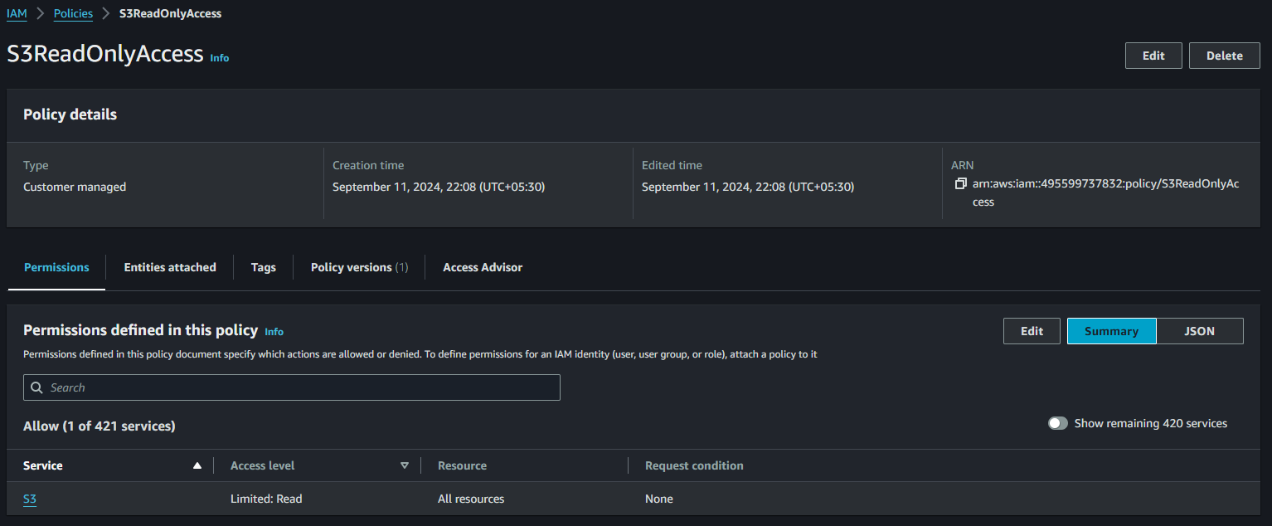

1. Now, attach this policy to the Developers group:
   * Go to Groups in the IAM Console.
   * Select Developers, then go to the Permissions tab.
   * Click Attach Policy and search for S3ReadOnlyAccess.
   * Select it and click Attach Policy.

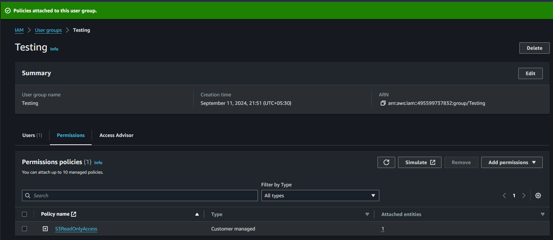

**29. Login with User A and Verify S3 Read-Only Access**

1. Open an incognito/private browser and go to the AWS Management Console.
2. Use the UserA credentials and change the password when prompted.
3. Verify that UserA can only access S3 with read-only access:
   * Open the S3 service and attempt to list buckets (it should work).
   * Try creating or deleting a bucket (it should fail).

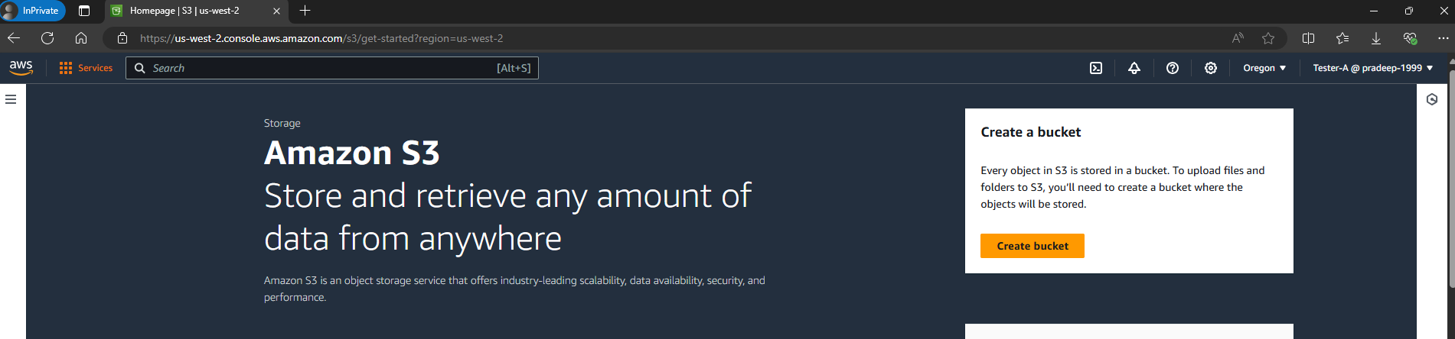

**30. Create Tester-B**

1. Follow the same steps as Step 2 to create Tester-B.
2. Do not add Tester-B to any group for now.

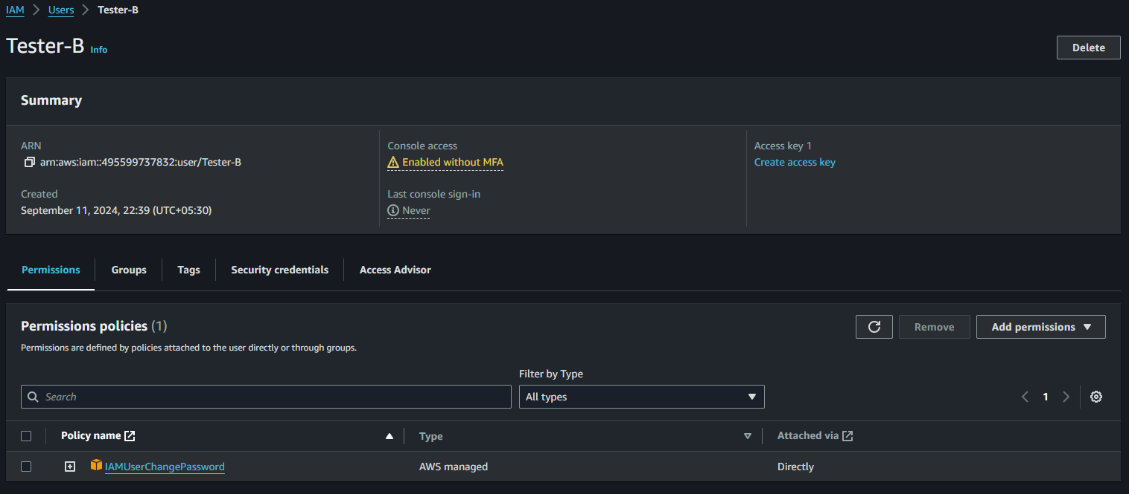

**31. Create EC2 and S3 Full Access Policy for Tester-B**

1. Go to Policies in the IAM Console and create a new policy.
2. In the JSON tab, paste the following policy for full access to both EC2 and S3:
3. Name the policy EC2S3FullAccess and create it.

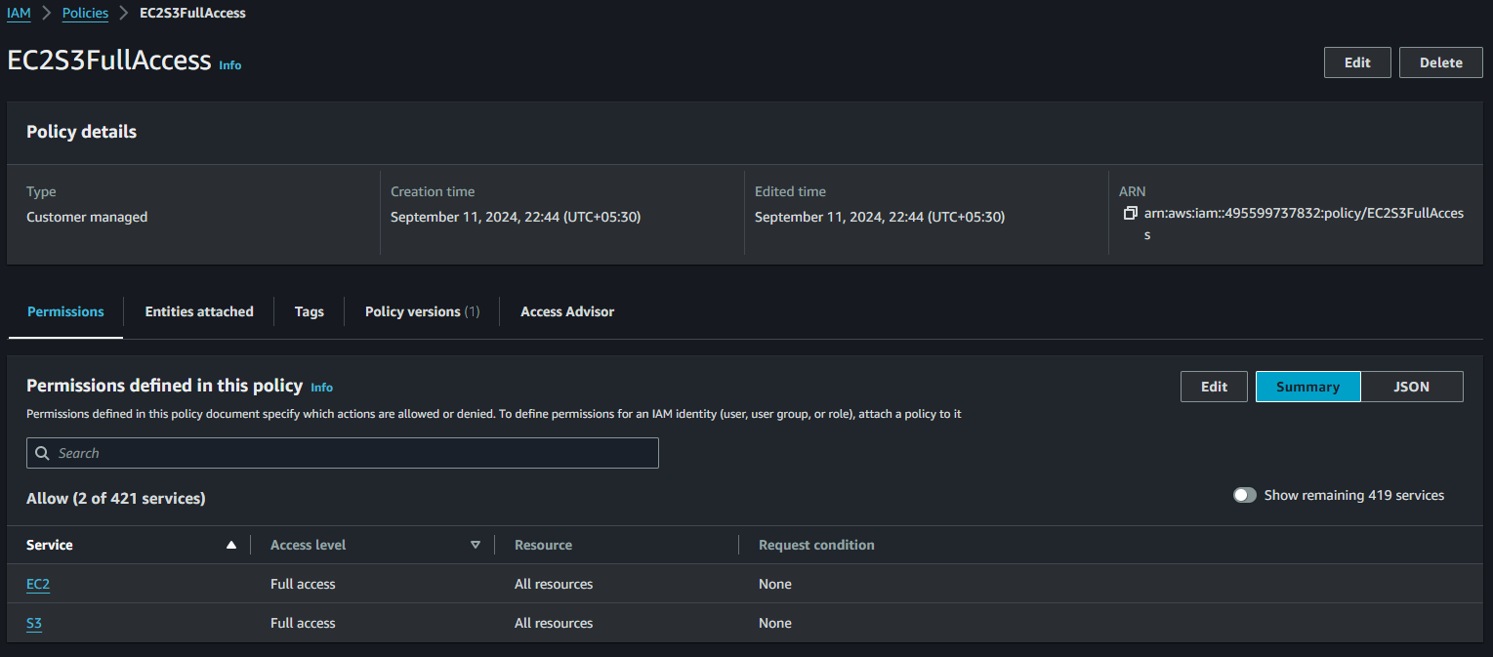

1. Attach this policy directly to Tester-B:
   * Go to Users, select Tester-B, and under the Permissions tab, click Add permissions.
   * Select Attach existing policies directly.
   * Search for and select the EC2S3FullAccess policy.
   * Click Next: Review and Add Permissions.

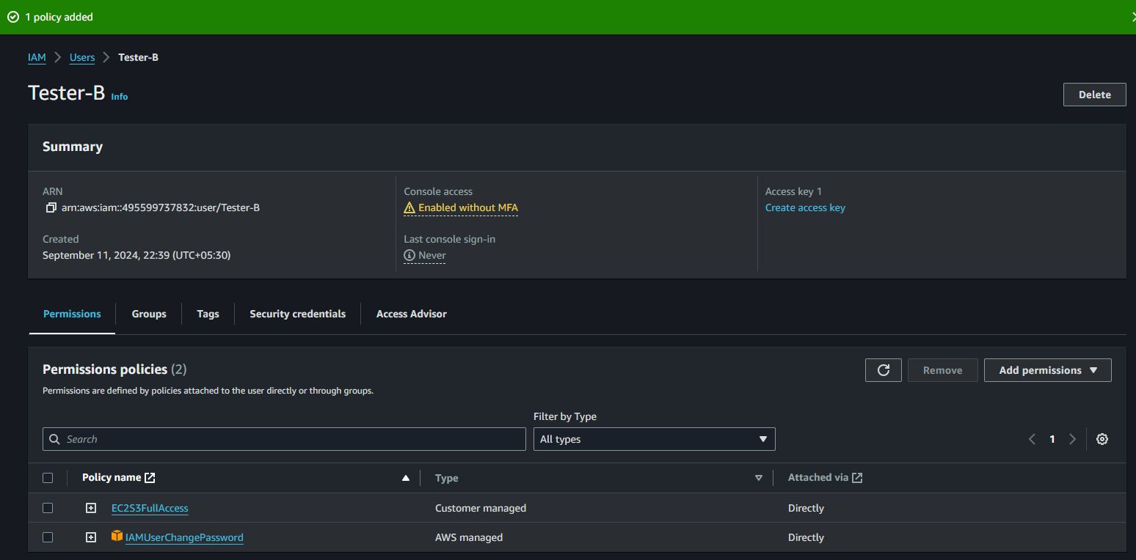

**32. Verify User B’s Access to EC2 and S3**

1. Login as Tester-B in the AWS Console and verify:
   * S3: You should have full access (create, list, delete, etc.).
   * EC2: You should be able to start, stop, and manage EC2 instances.

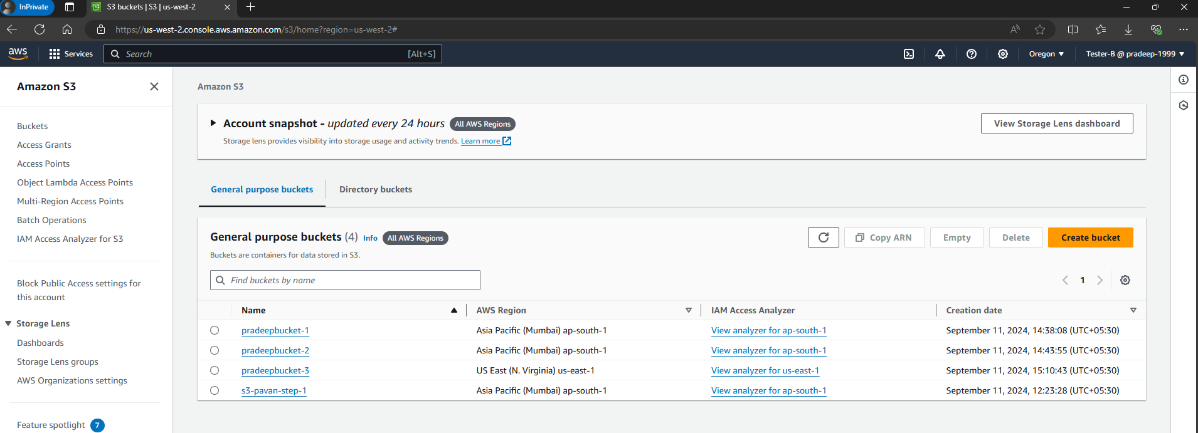

**33. Create User C and Attach S3 + EC2 List-Only Policy via Policy Creator UI**

1. Follow the same process as step – 27 to create Tester-C.

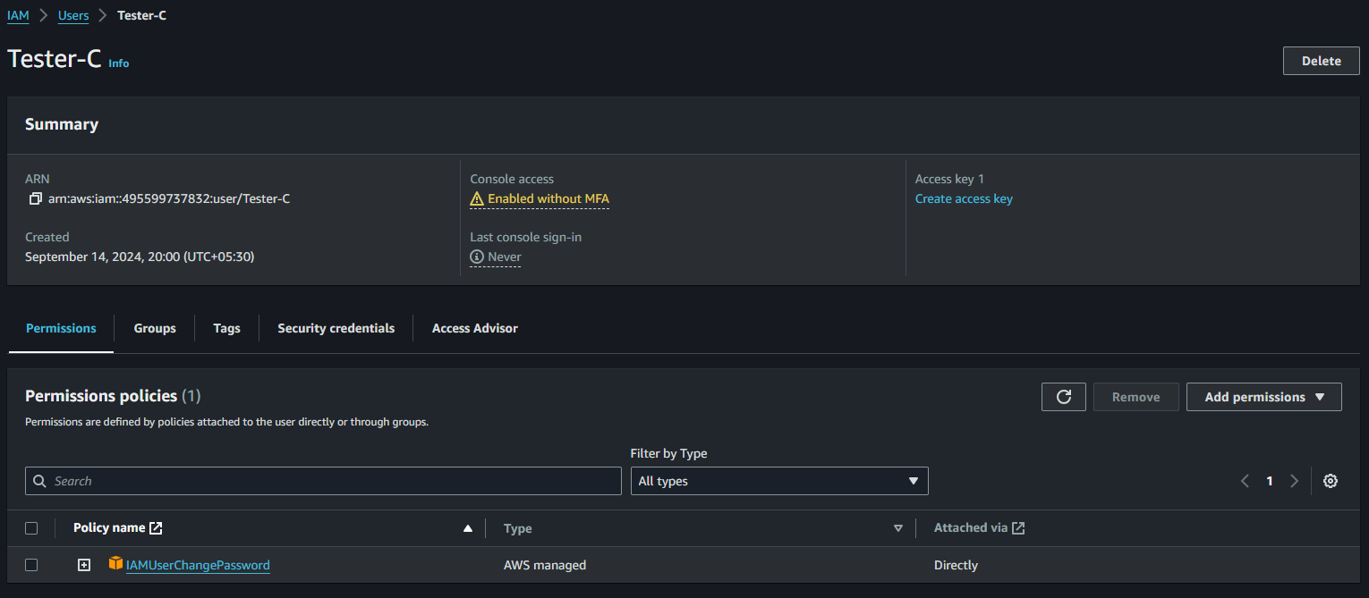

1. In the IAM Console, use the Policy Creator UI:
   * Create a policy to allow only listing of S3 and EC2 resources:
     + Use the Visual Editor to select S3 and allow ListBucket action.
     + Add EC2 actions to allow DescribeInstances.

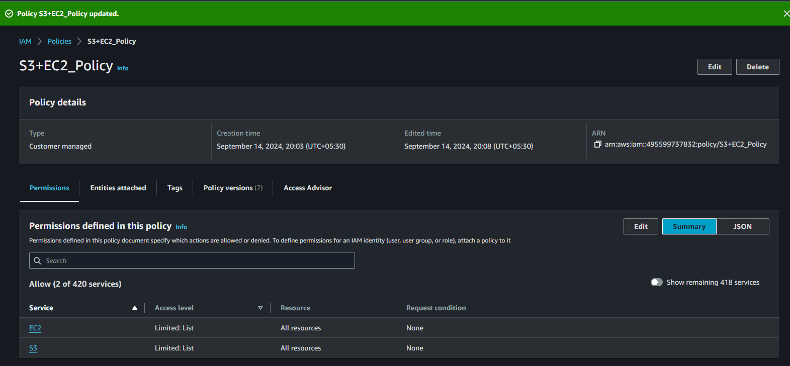

* + Attach this policy to Tester-C.

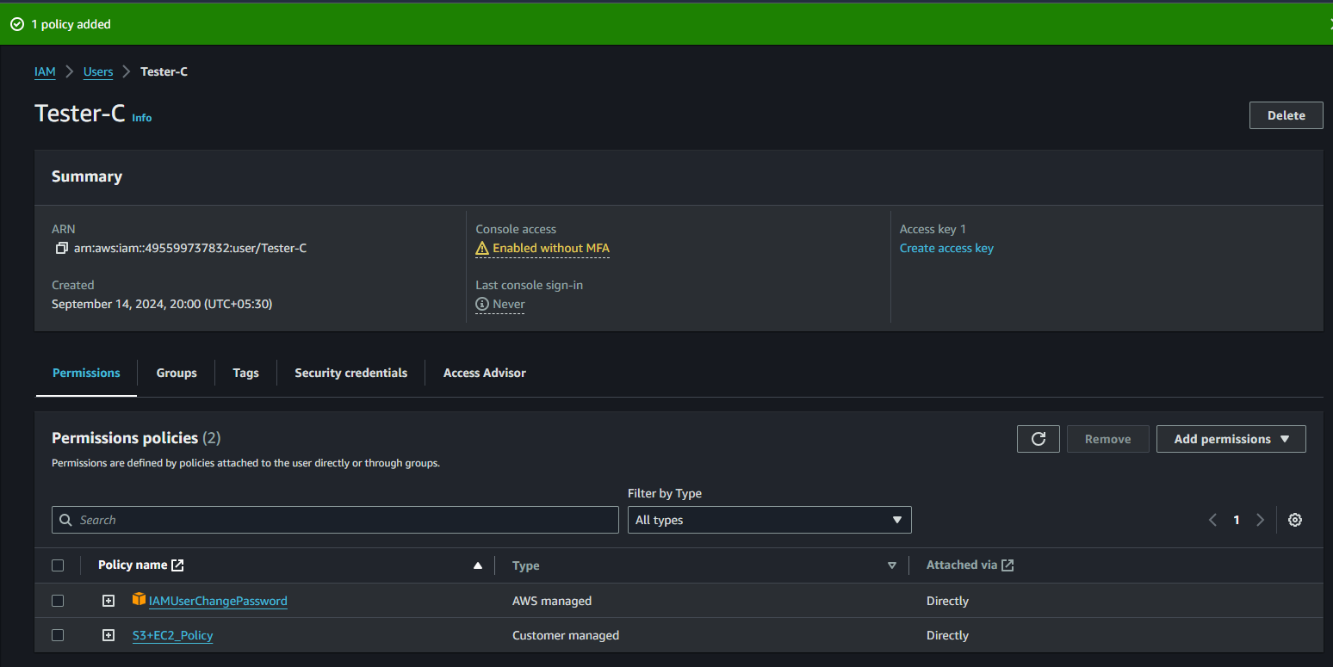

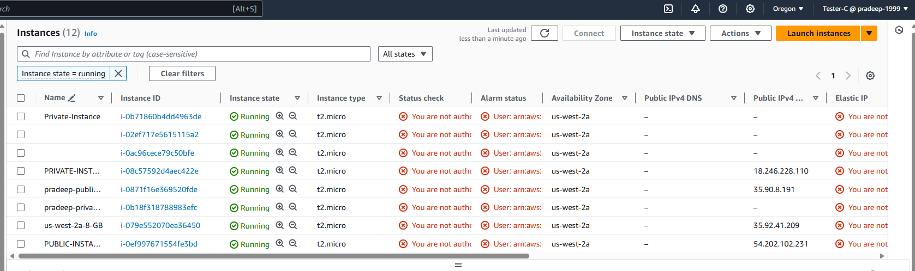

**34.Create Access and Secret Keys for AWS CLI Configuration**

1. In the IAM Console, go to Users.
2. Select Tester-B and under the Security Credentials tab, click Create access key.
3. Save the Access Key ID and Secret Access Key.

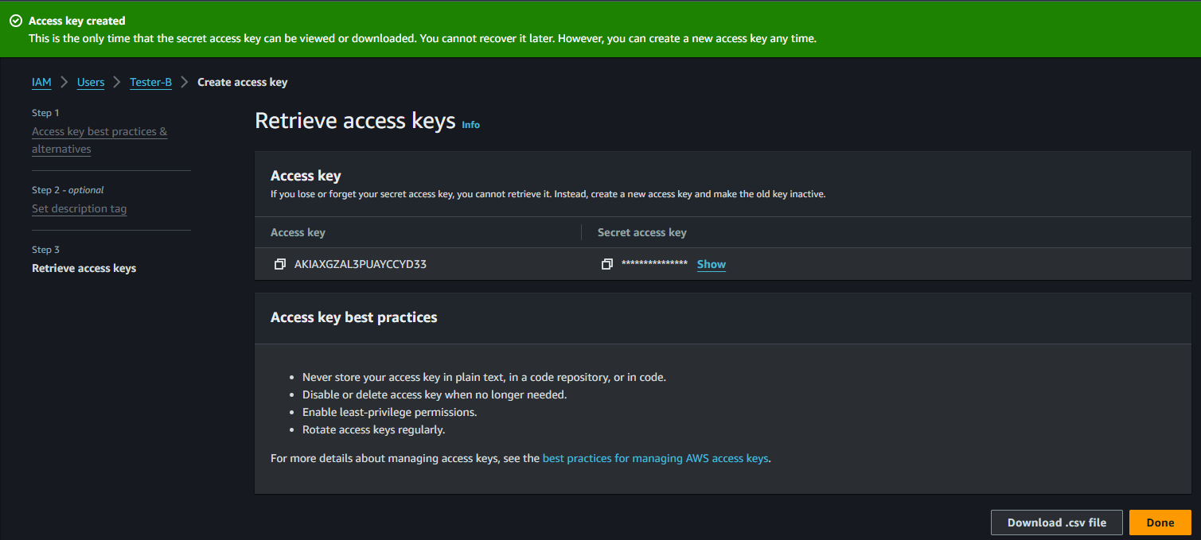

1. Install the AWS CLI on your local machine (Windows):
   * Follow the [AWS CLI installation guide](https://docs.aws.amazon.com/cli/latest/userguide/getting-started-install.html).
2. Configure the CLI by running the following command in the command prompt:

**35. Create S3 Bucket Using AWS CLI**

Run the following command to create an S3 bucket:

* aws s3api create-bucket --bucket pavan9876-test-bucket --region us-west-2 --create-bucket-configuration LocationConstraint=us-west-2



**36. create ec2 instance using aws cli**

Use the AWS CLI to launch an EC2 instance:

* aws ec2 run-instances \

--image-id ami-05134c8ef96964280 \

--instance-type t2.micro \

--key-name pradeep \

--region us-west-2 \

--subnet-id subnet-07eedd168e96b6c58 \

--associate-public-ip-address

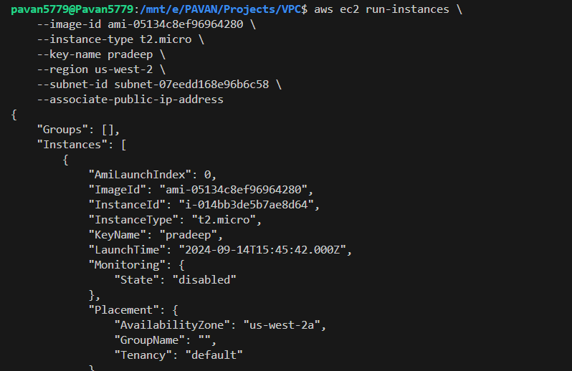

**37.Create IAM user Using AWS CLI**

Create a new IAM user via the AWS CLI:

* aws iam create-user --user-name Tester-D

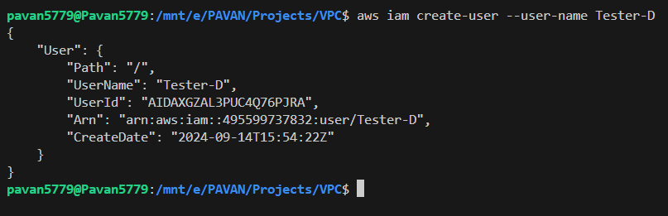

**38.Create Policy Using AWS CLI**

Create a new policy using the following command:

* aws iam create-policy --policy-name S3ReadOnly --policy-document '{"Version":"2012-10-17","Statement":[{"Effect":"Allow","Action":"s3:Get*","Resource":"*"}]}'

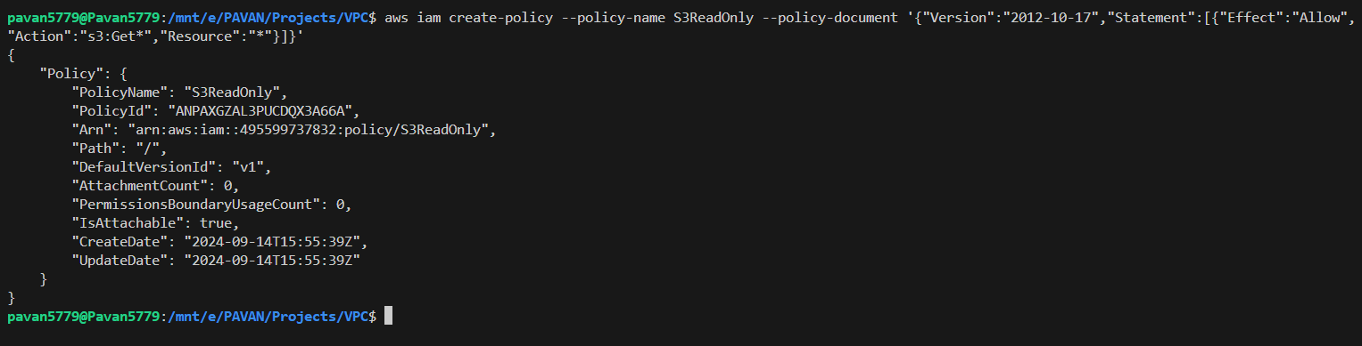

**39.Attach Policy to User Using AWS CLI**

Attach the policy to a user via the CLI:



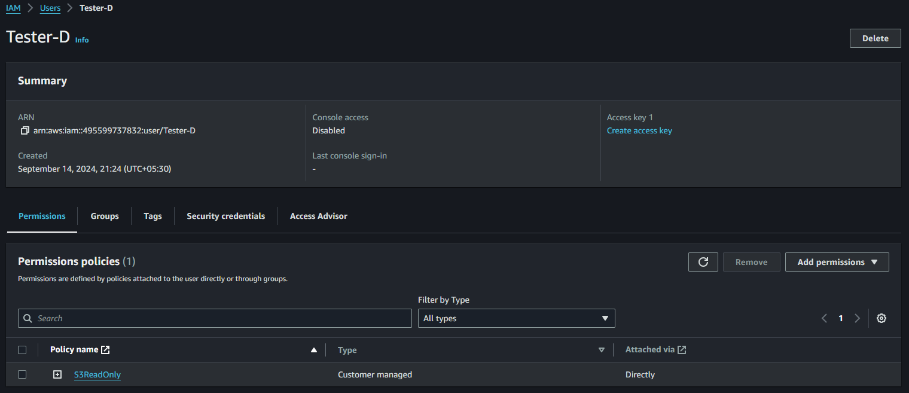

**40. Create pk-bucket-1234 in the ap-south-1 region and upload files (T1, T2, T3)**

**Create Bucket:**

* Go to the S3 Dashboard.
* Click Create bucket.
* Enter a name pk-bucket-1234, select ap-south-1 as the region, and leave the default settings.
* Click Create bucket.

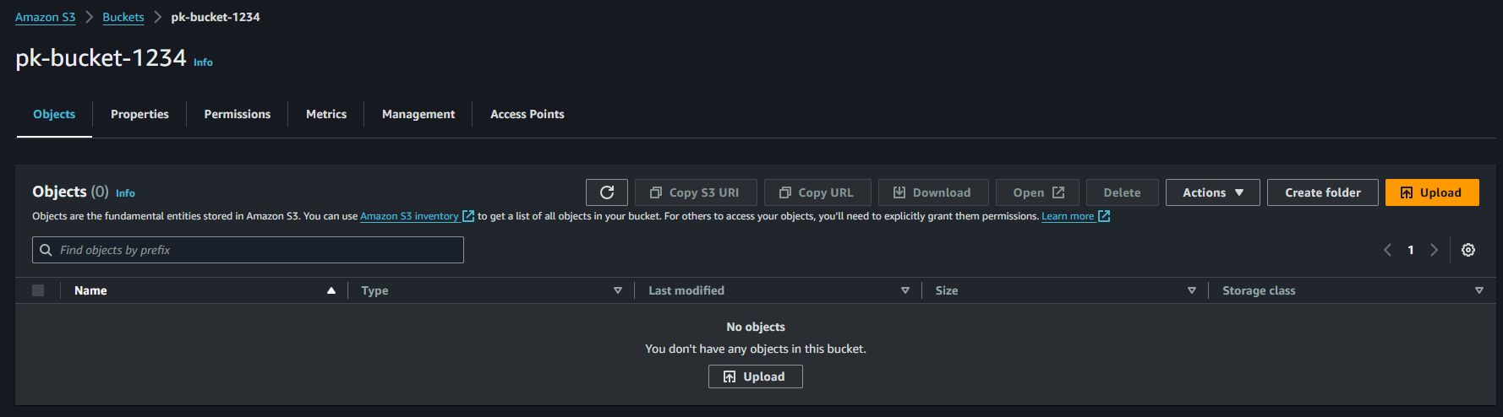

**Upload Files:**

* Open pk-bucket-1234.
* Click on Upload and add the files t1, t2, and t3.
* Click Upload to confirm.

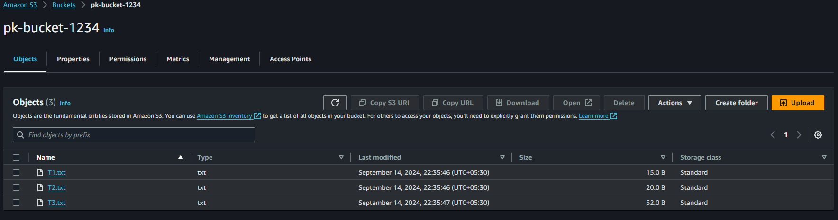

**CLI**

**40. Create kalyan-bucket-987 and upload files**

* aws s3api create-bucket --bucket kalyan-bucket-987 --region ap-south-1 --create-bucket-configuration LocationConstraint=ap-south-1



* aws s3 cp t1.txt s3://kalyan-bucket-987/
* aws s3 cp t2.txt s3://kalyan-bucket-987/
* aws s3 cp t3.txt s3://kalyan-bucket-987/

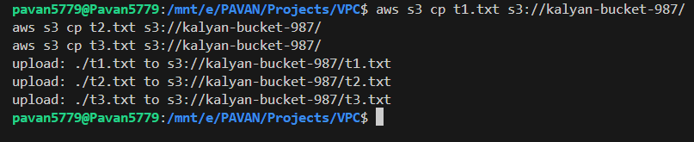

**41. Create pk-bucket-2468 in the ap-south-1 region and upload files (T4, T5, T6)**

**Create Bucket:**

* Enter name it pk-bucket-2468 and use the ap-south-1 region.
* Click Create bucket.

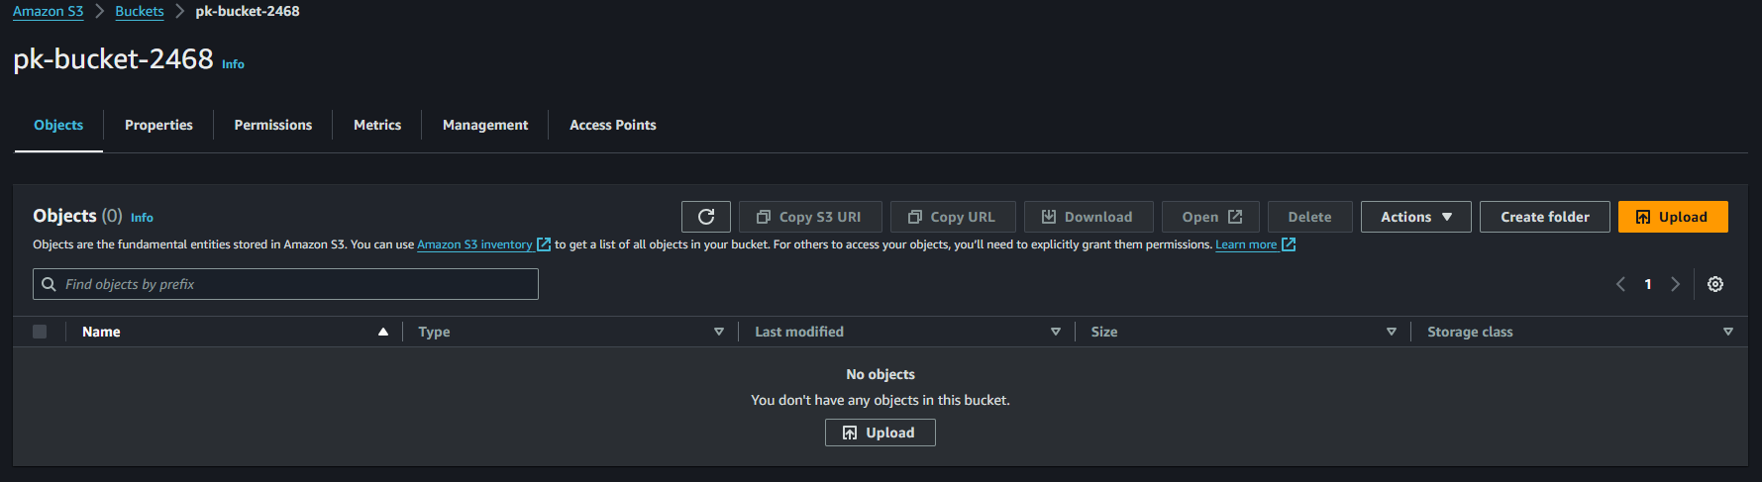

**Upload Files:**

* Open pk-bucket-2468 and upload files T4, T5, and T6.

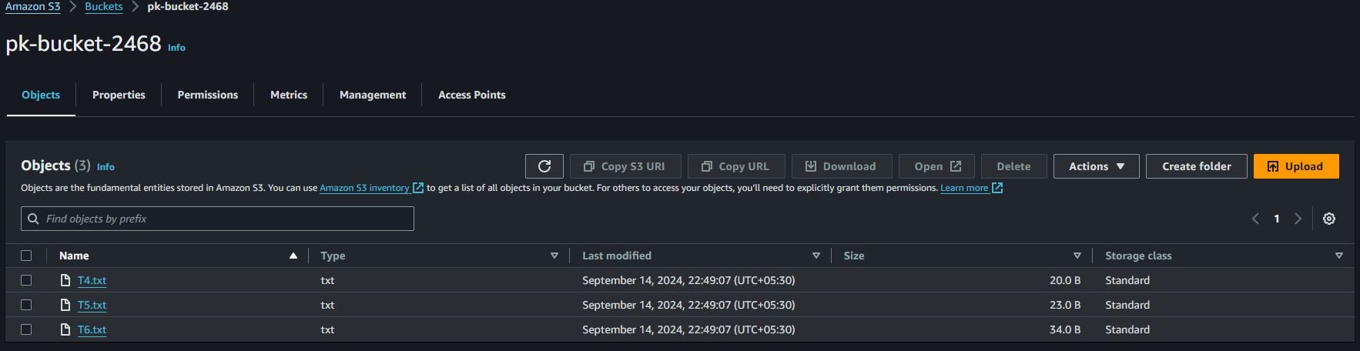

**41. Create kalyan-bucket-786 in the ap-south-1 region and upload files (T4, T5, T6)**

* aws s3api create-bucket --bucket kalyan-bucket-786 --region ap-south-1 --create-bucket-configuration LocationConstraint=ap-south-1



* aws s3 cp t4.txt s3://kalyan-bucket-786/
* aws s3 cp t5.txt s3://kalyan-bucket-786/
* aws s3 cp t6.txt s3://kalyan-bucket-786/

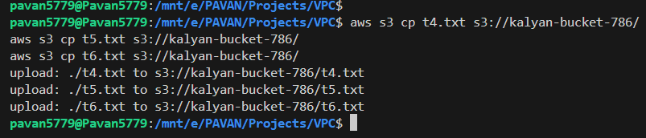

**42.Copy files from pk-bucket-1234 to pk-bucket-2468**

**Copy Files:**

* Go to pk-bucket-1234, select the files t1, t2, t3.
* Click Actions → Copy.
* Navigate to pk-bucket-2468 and click Actions → Paste.

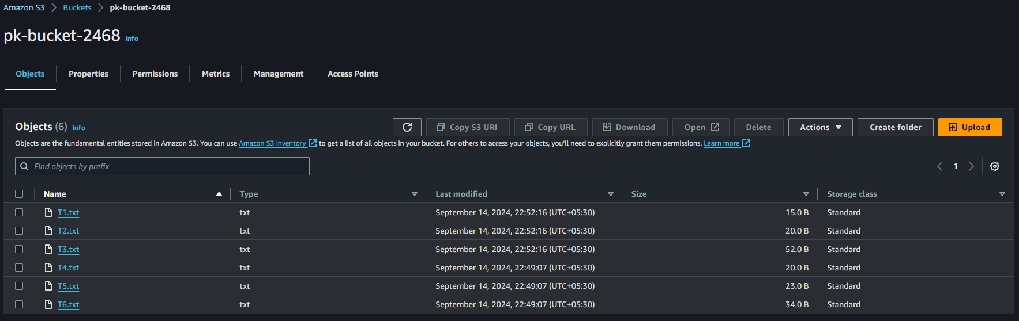

**42.Copy files from kalyan-bucket-987 to kalyan-bucket-786**

* aws s3 cp s3://kalyan-bucket-987/ s3://kalyan-bucket-786/ --recursive

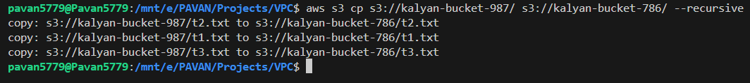

**43.Create pk-buket-369 in the us-west-2 region and upload files (T7, T8, T9)**

**Create Bucket:**

* Create pk-bucket-369 in the us-west-2 region.
* Click Create bucket.

**Upload Files:**

* Open pk-bucket-369 and upload files T7, T8, and T9.

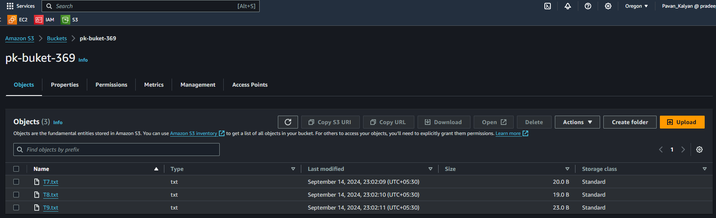

**43.Create kalyan-buket-369 in the us-west-2 region and upload files (T7, T8, T9)**

* aws s3api create-bucket --bucket kalyan-bucket-369 --region us-west-2 --create-bucket-configuration LocationConstraint=us-west-2



* aws s3 cp t7.txt s3://kalyan-bucket-369/
* aws s3 cp t8.txt s3://kalyan-bucket-369/
* aws s3 cp t9.txt s3://kalyan-bucket-369/

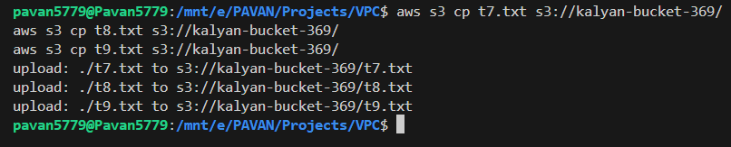

**44: Copy files from pk-bucket-1234 (ap-south-1) to pk-bucket-369 (us-west-2)**

**Copy Files:**

* Go to bucket-1, select the files, and click Copy.
* Go to bucket-3 and paste the files.

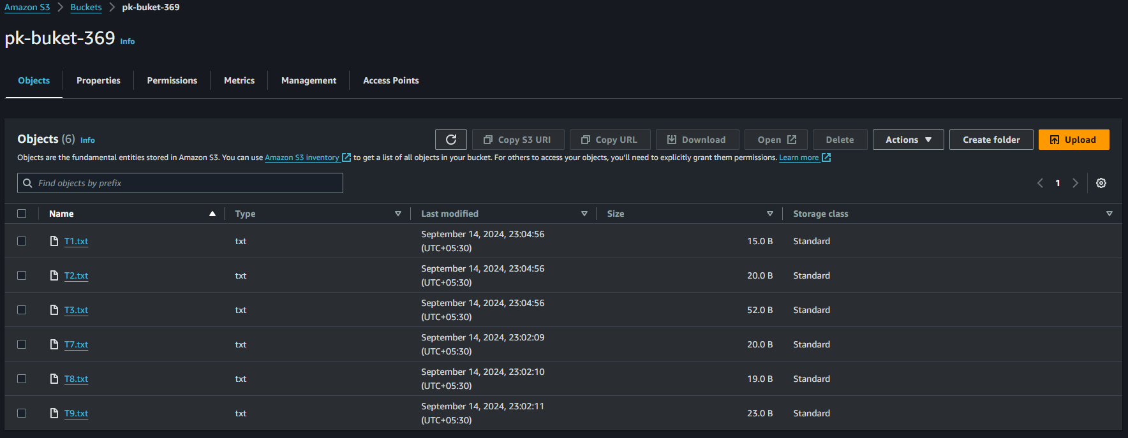

**44: Copy files from kalyan-bucket-987 (ap-south-1) to kalyan-bucket-369 (us-west-2)**

* aws s3 cp s3://kalyan-bucket-987/ s3://kalyan-bucket-369/ --recursive

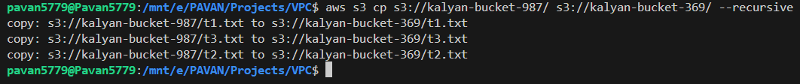

**45: Make pk-bucket-1234 a static website host**

1. Configure Static Website Hosting:

* Open pk-bucket-1234, go to the Properties tab.
* Scroll down to Static website hosting.
* Enable it, enter index.html as the index document.

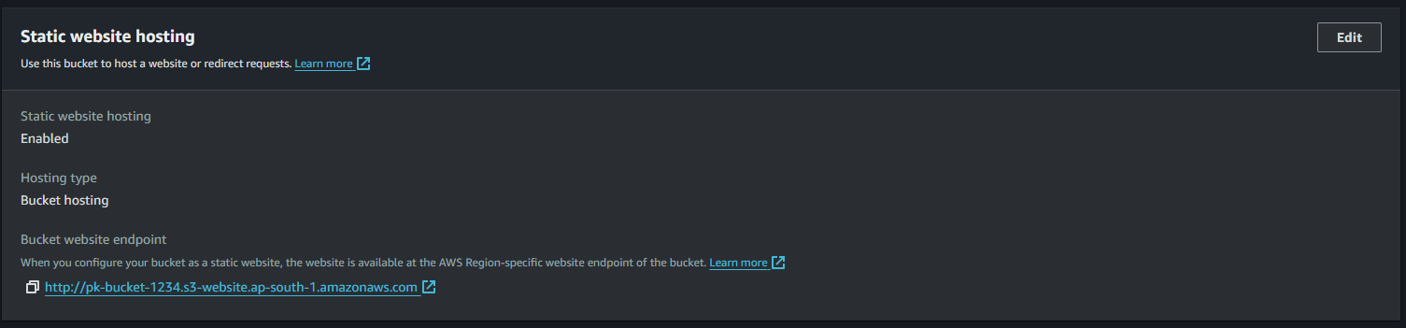

1. Set Bucket Policy:

* Go to Permissions → Bucket Policy.
* Add a public read policy for your bucket:

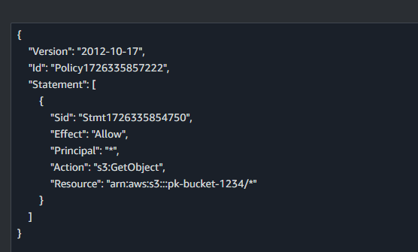

1. Disable ACLs:

* Go to Permissions and disable ACLs for the bucket.

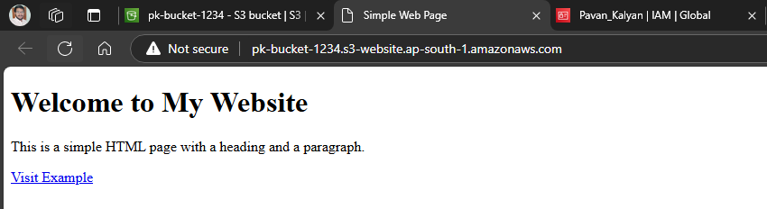

**45: Make pk-bucket-987 a static website host**

**Disable Block Public Access**

* aws s3api put-public-access-block --bucket kalyan-bucket-987 --public-access-block-configuration BlockPublicAcls=false,IgnorePublicAcls=false,BlockPublicPolicy=false,RestrictPublicBuckets=false
* aws s3 website s3://bucket-1/ --index-document index.html
* aws s3api put-bucket-policy --bucket kalyan-bucket-987 --policy <file://policy.json>

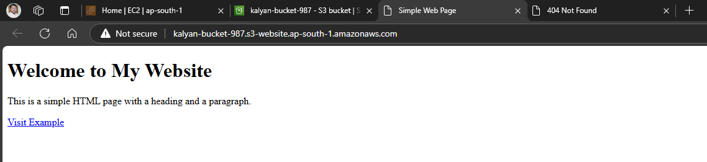

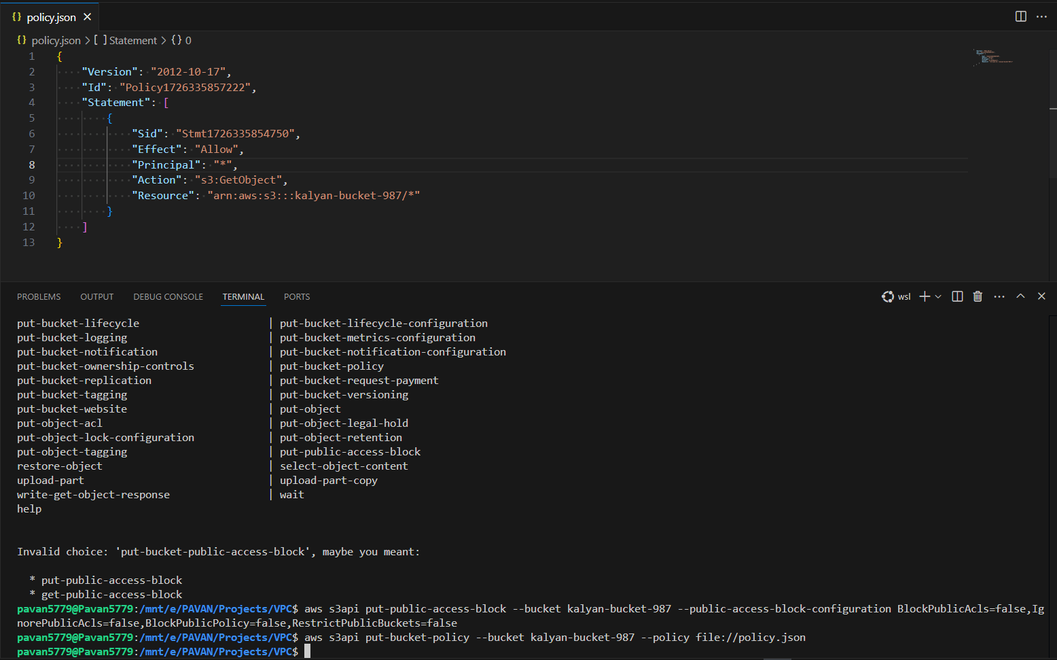

**46: Access pk-bucket-2468 from an EC2 instance in a private subnet**

1. Create EC2 Instance:
   * Launch an EC2 instance in a private subnet within a VPC.
   * Attach an IAM Role to the instance with S3 access permissions.
2. Access S3 from EC2:
   * SSH into the EC2 instance and use the following command to list objects from pk-bucket-2468:

**Access S3 from the Private EC2 Instance**

1. Install AWS CLI (if not installed):

* sudo apt update
* sudo apt install awscli -y

1. Configure AWS CLI (ensure the instance can access S3 via IAM role):

* aws configure

1. List Objects in Bucket-2:

* Run the following command to check if you can access bucket-2:
* aws s3 ls s3://pk-bucket-2468

1. If the EC2 instance can list the objects in the bucket, the S3 access is working correctly from the private subnet.

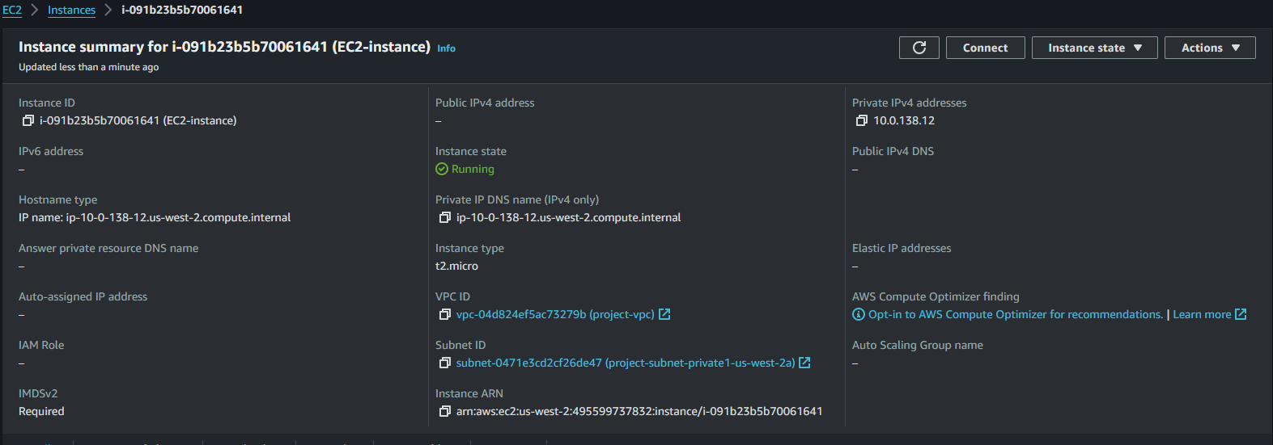

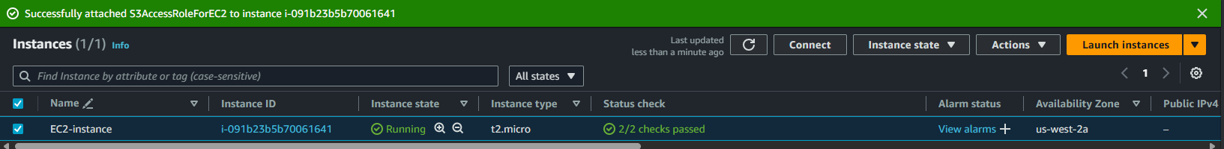

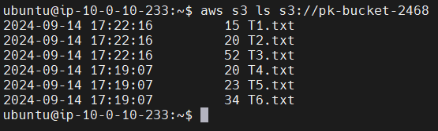

**47. Block Only One IP Address on pk-Bucket-2468**

1. Open the AWS S3 console

* Log in to your AWS Management Console.
* Navigate to the S3 service by searching for "S3" in the AWS Services search bar.

2. Select pk-bucket-2468

* In the S3 Dashboard, find pk-Bucket-2468 (the bucket where you want to block an IP address).
* Click on the bucket name (pk-Bucket-2468) to open it.

3. Open bucket permissions

* Once inside pk-Bucket-2468, click on the Permissions tab.
* Scroll down to the Bucket Policy section.
* Click Edit to modify the current policy.

4. Add a policy to block an IP Address

* You will add a policy that denies all access to objects in the bucket from the specific IP address.
* In the Bucket Policy Editor, add the following JSON policy:

5. Verify the policy

* Try accessing any object in pk-Bucket-2468 from an IP address other than 34.215.161.77. You should be able to access the files.
* From the IP address 34.215.161.77, access will be denied.

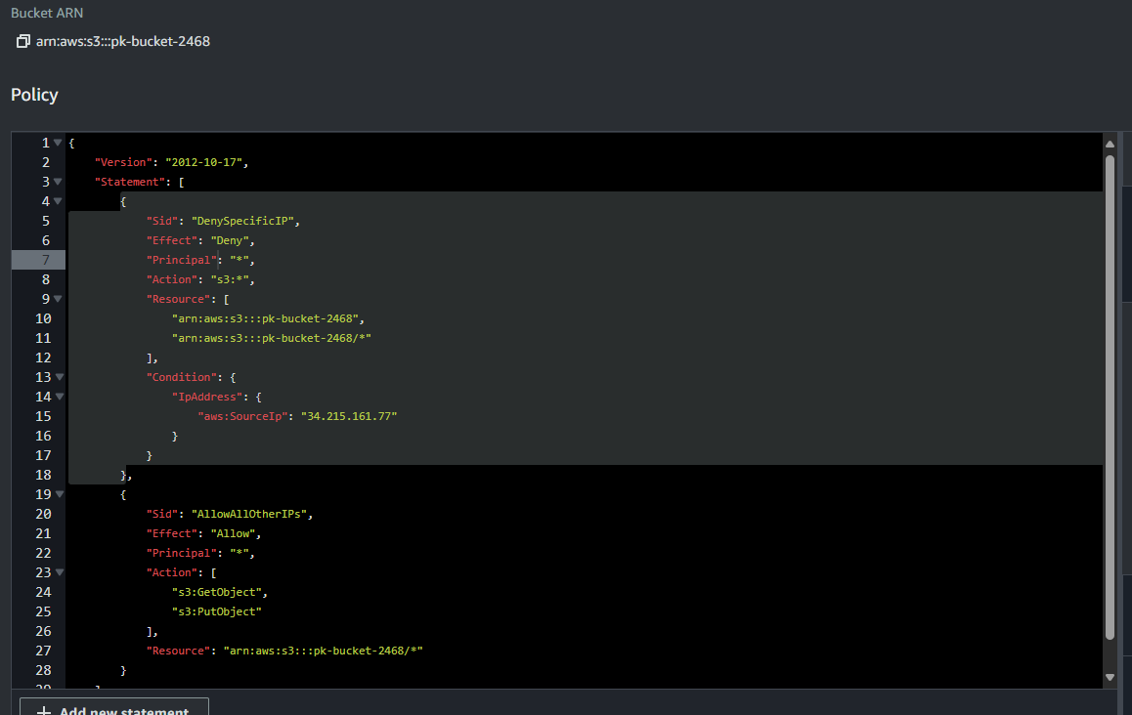

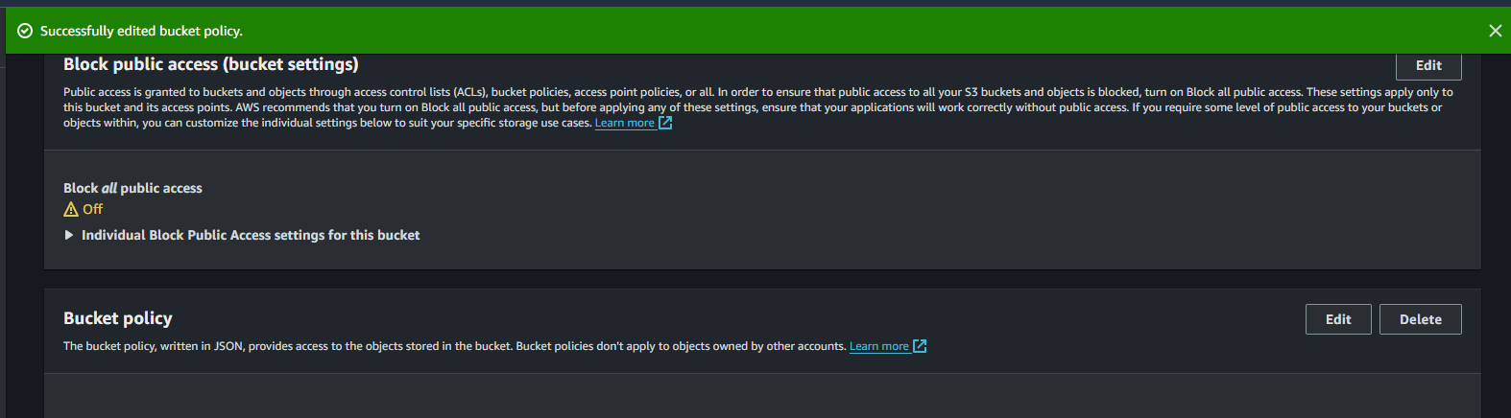



**48. Allow Only One IP Address on pk-Bucket-369**

1. Open the AWS S3 console

* Log in to your AWS Management Console.
* Navigate to the S3 service by searching for "S3" in the AWS Services search bar.

2. Select pk-bucket-369

* In the S3 Dashboard, find pk-Bucket-369 (the bucket where you want to Allow an IP address).
* Click on the bucket name (pk-Bucket-369) to open it.

3. Open bucket permissions

* Once inside pk-Bucket-369, click on the Permissions tab.
* Scroll down to the Bucket Policy section.
* Click Edit to modify the current policy.

4. Add a policy to allow an IP Address

* You will add a policy that denies all access to objects in the bucket from the specific IP address.
* In the Bucket Policy Editor, add the following JSON policy:

5. Verify the policy

* Try accessing any object in pk-Bucket-369 from an IP address other than 34.215.161.77. You should be able to access the files.

From the IP address 34.215.161.77, access will be allowed.

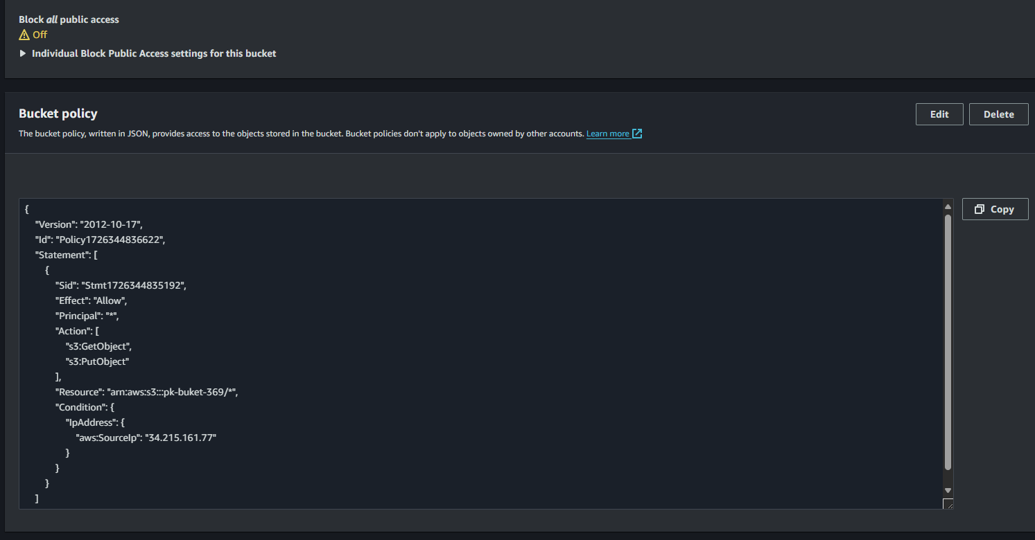



**49. Take the sample application NodeJS and build it- > deploy to s3**

You can either create a new sample application or clone an existing one.

* mkdir sample-app
* cd sample-app
* npm init -y

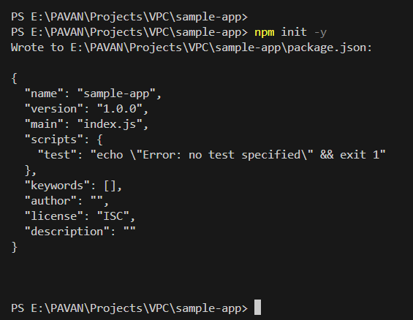

**Next, create a simple Node.js app:**

* touch app.js

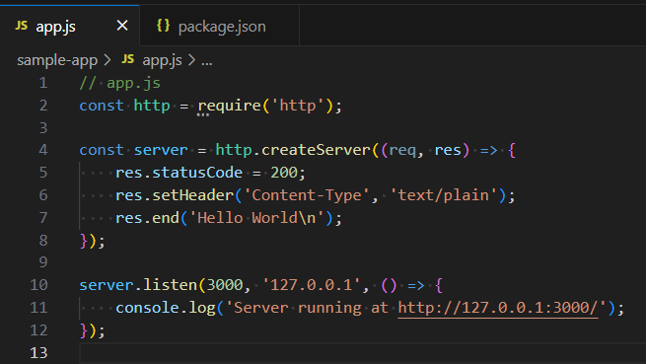

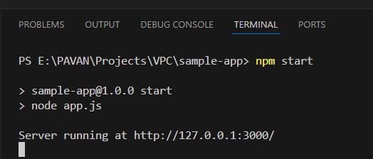

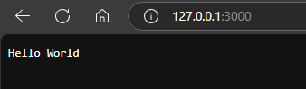

**Create an S3 Bucket**

Go to the AWS Management Console and create an S3 bucket to hold the application files. For example:

* Bucket Name: sample-app-bucket-987654
* Region: Select the region of your choice us-west-2

**5. Upload the Application to S3**

After building the application and zipping it, you can manually upload the .zip file to the S3 bucket via the AWS console.

1. Navigate to your S3 bucket in the AWS Console.
2. Click Upload.
3. Select the sample-app.zip file.
4. Click Upload to complete the process.

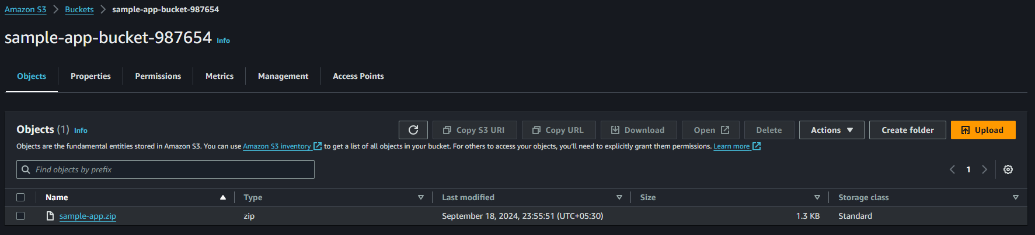

**Full Shell Script**

**Here is the shell script to automate the entire process:**

**Execution of the Shell Script**

1. Save the script in a file (e.g., deploy_to_s3.sh).
2. Give execute permission to the script:
   * chmod +x deploy_to_s3.sh
3. Run the script:
   * ./deploy_to_s3.sh

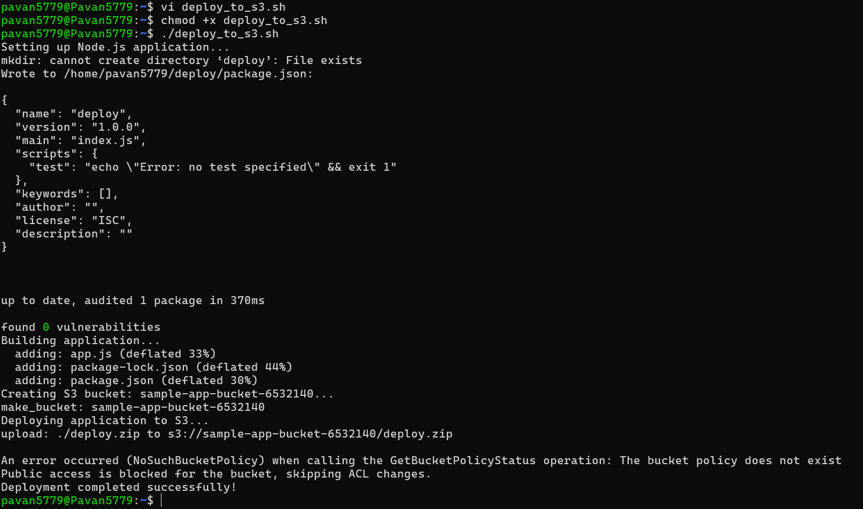

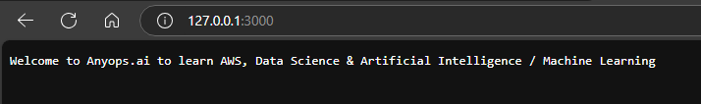

* This script handles everything, from setting up a basic Node.js application to deploying the zipped version to an S3 bucket. You can modify it as needed based on your project's requirements.

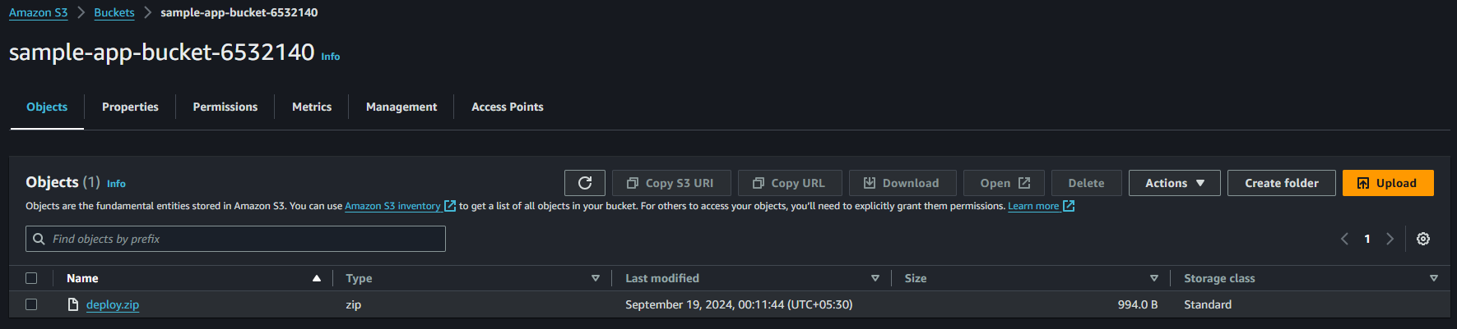

**Task 50: Create an Alarm for a Specific EC2 Instance to Monitor Network Load and Send Alerts via SNS**

**Using AWS Console:**

1. **Open CloudWatch:**
   * Go to the AWS Management Console.
   * In the Services menu, search for and select CloudWatch.
2. **Navigate to Alarms:**
   * On the left-hand menu, click on Alarms.
   * Click the Create Alarm button.
3. **Select Metric:**
   * Choose Select metric.
   * In the search box, type EC2 and select Per-Instance Metrics.
   * Choose the instance you want to monitor.
   * Select the metric Network in or Network Out (to monitor incoming or outgoing network traffic).
   * Click Select metric.
4. **Set Conditions:**
   * Set the threshold for the alarm. For example, you can set a condition where the network load exceeds 100,000 bytes.
   * Choose Static and set the threshold value.
   * Set the period (e.g., 5 minutes).
5. **Add Notification:**
   * Under the Notification section, select In Alarm.
   * Choose Create new topic, give it a name, and add an email for notifications.
   * You'll receive a confirmation email to this address. Make sure to confirm it.
6. **Create Alarm:**
   * Click Create Alarm.

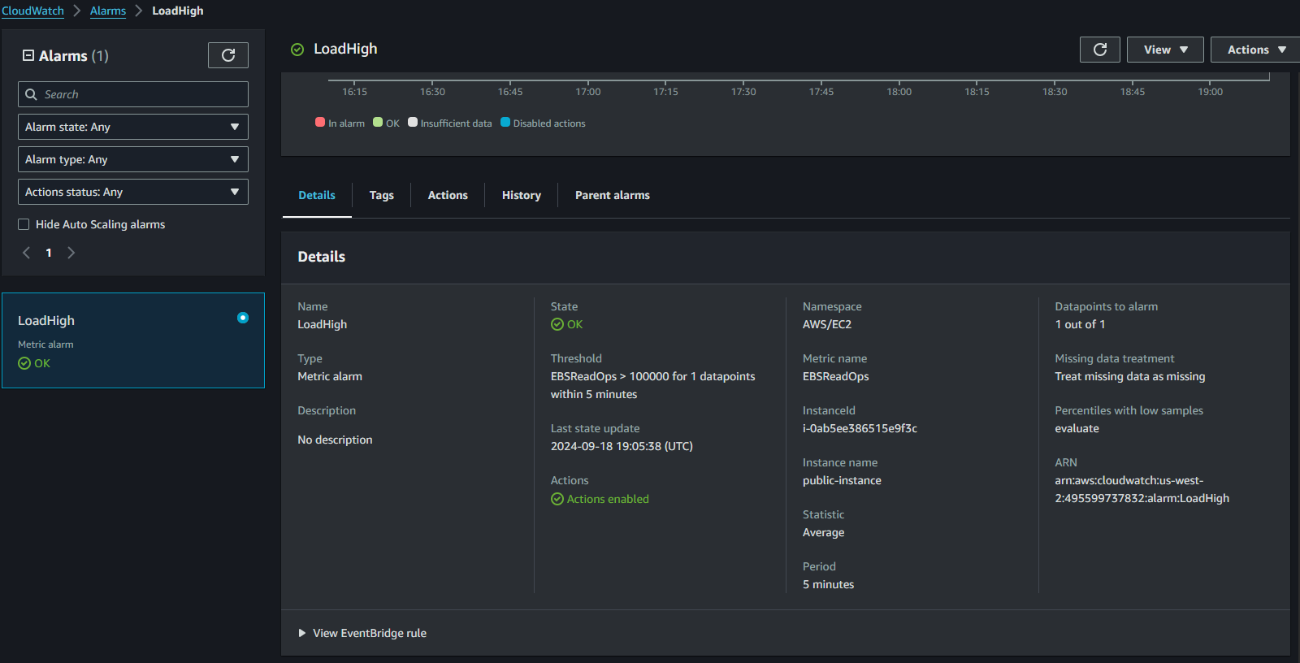

**Using AWS CLI:**

**Create SNS Topic:**

* aws sns create-topic --name NetworkLoadAlarm

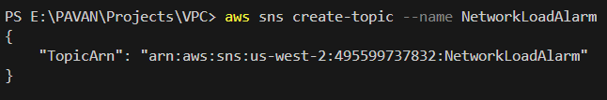

**Subscribe an Email to the SNS Topic:**

* aws sns subscribe --topic-arn arn:aws:sns:us-west-2:495599737832:NetworkLoadAlarm --protocol email --notification-endpoint [pavankalyanmeda5779@gmail.com](mailto:pavankalyanmeda5779@gmail.com)



**Create CloudWatch Alarm:**

* aws cloudwatch put-metric-alarm \

--alarm-name NetworkLoadHigh \

--metric-name NetworkIn \

--namespace AWS/EC2 \

--statistic Average \

--period 300 \

--threshold 100000 \

--comparison-operator GreaterThanThreshold \

--dimensions Name=InstanceId,Value= i-0ab5ee386515e9f3c \

--evaluation-periods 1 \

--alarm-actions arn:aws:sns:us-west-2:495599737832:NetworkLoadAlarm \

--unit Bytes



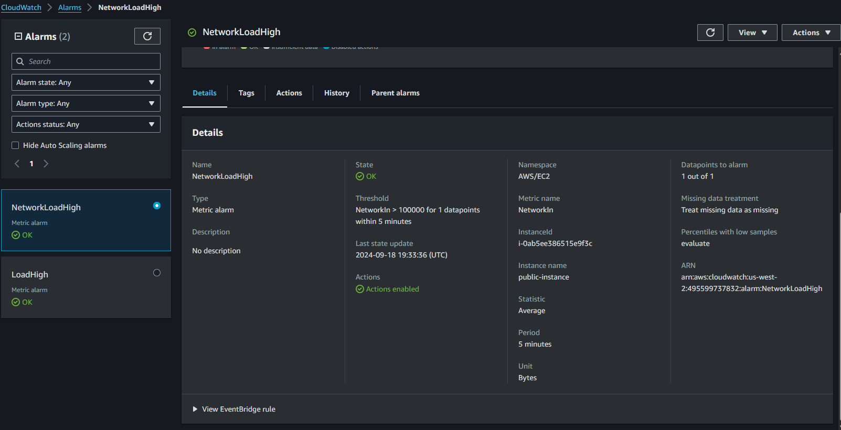

**Task 51: Create an SNS Topic and Add an Email Address for Notifications**

**Using AWS Console:**

1. **Open SNS Service:**
   * In the AWS Console, search for Simple Notification Service (SNS).
2. **Create Topic:**
   * In the SNS Dashboard, click Topics in the left pane.
   * Click Create topic.
   * Choose Standard for the topic type.
   * Enter a name for your topic (e.g., MyNotificationTopic).
   * Click Create topic.
3. **Subscribe an Email Address:**
   * After creating the topic, click Create subscription.
   * For Protocol, select Email.
   * Enter the email address you want to receive notifications.
   * Click Create subscription.
4. **Confirm Subscription:**
   * Check your inbox for a confirmation email and click on the confirmation link.

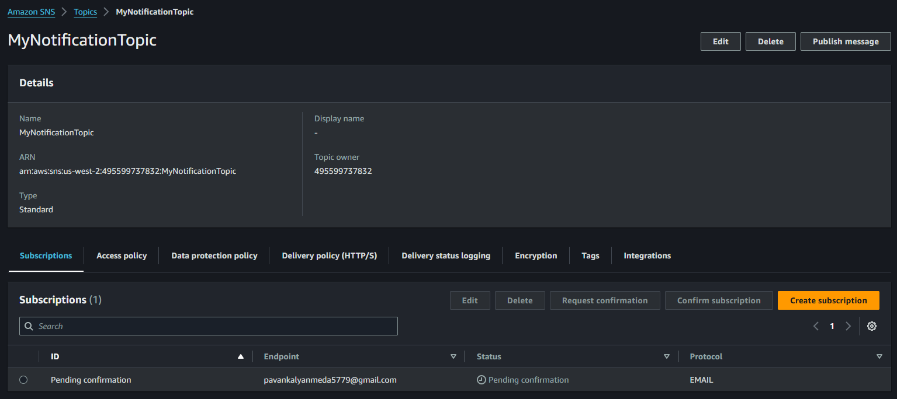

**Using AWS CLI:**

1. **Create SNS Topic:**

* aws sns create-topic --name MyTopic

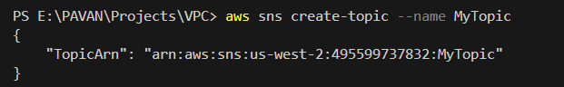

1. **Subscribe an Email Address:**

* aws sns subscribe --topic-arn arn:aws:sns:us-west-2:495599737832:MyTopic --protocol email --notification-endpoint pavankalyanmeda5779@gmail.com



1. **Confirm Subscription:**
   * Open the confirmation email sent to your email address and confirm the subscription.

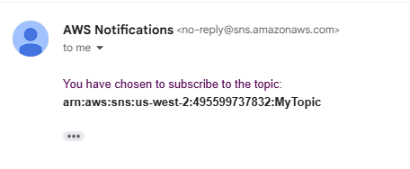

**Task 52: Create an SQS Queue and Subscribe it to the SNS Topic**

**Using AWS Console:**

1. **Open SQS Service:**
   * In the AWS Console, search for Simple Queue Service (SQS).
2. **Create a New Queue:**
   * Click Create queue.
   * Choose a name (e.g., MyNotificationQueue).
   * Set queue type to Standard.
   * Leave the default settings or configure as needed.
   * Click Create queue.
3. **Subscribe the Queue to SNS:**
   * Go back to SNS in the console.
   * Select your topic (e.g., MyNotificationTopic).
   * Click Create subscription.
   * For Protocol, choose SQS.
   * For Endpoint, select the ARN of the SQS queue you created.
   * Click Create subscription.

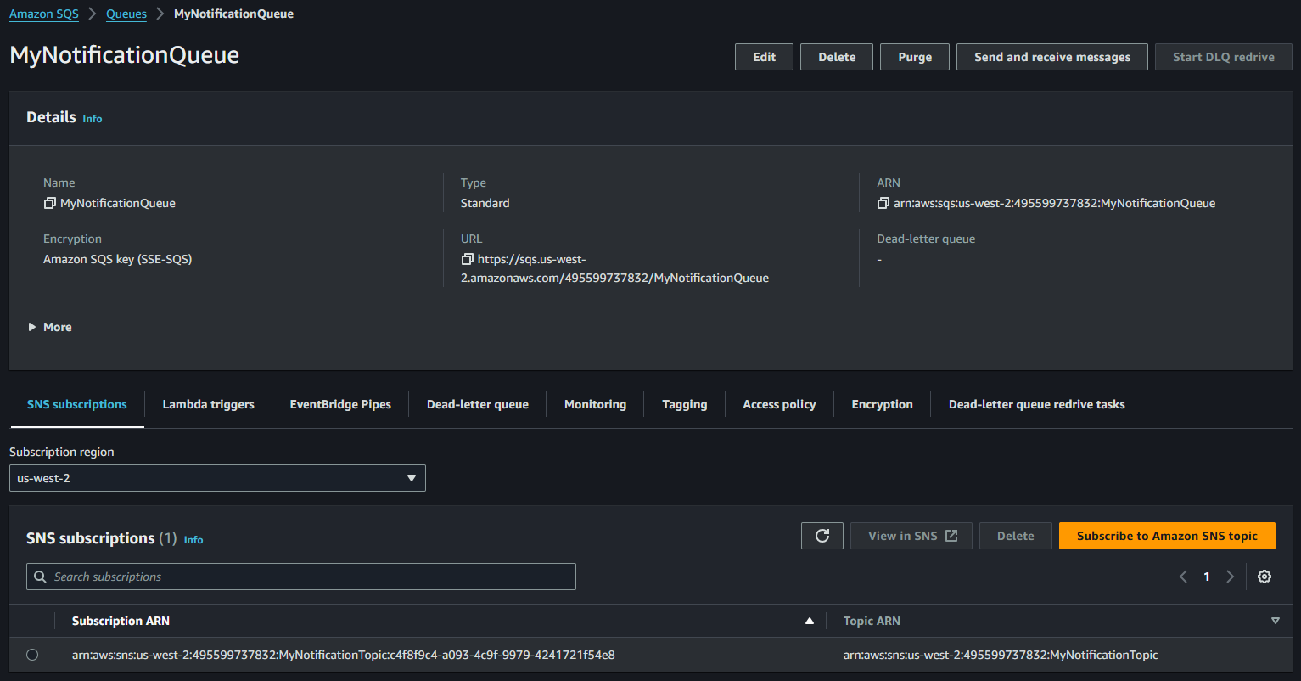

**Using AWS CLI:**

1. **Create SQS Queue:**

* aws sqs create-queue --queue-name MyQueue

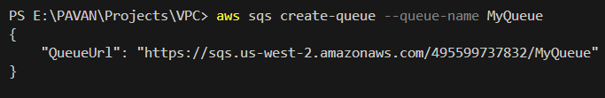

1. **Subscribe the SQS Queue to the SNS Topic:**

* aws sns subscribe --topic-arn arn:aws:sns:us-west-2:495599737832:MyTopic --protocol sqs --notification-endpoint arn:aws:sqs:us-west-2:495599737832:MyQueue



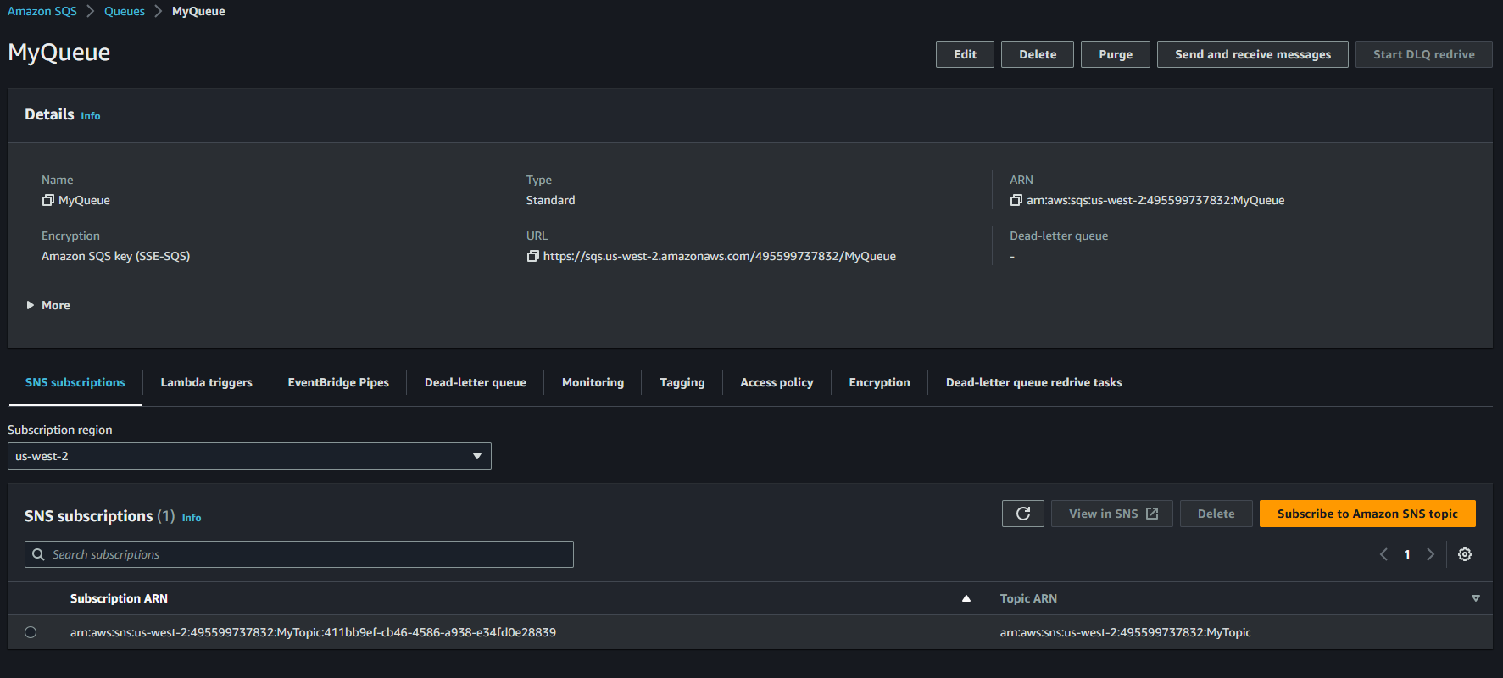

**Task 53: Verify Messages are Being Sent Correctly from SQS**

**Using AWS Console:**

1. **Send a Test Message to SNS Topic:**
   * Go to SNS and select the topic you created.
   * Click Publish message.
   * In the message body, enter a test message (e.g., Test message to verify SQS queue).
   * Click Publish message.
2. **Check SQS Queue for Messages:**
   * Go to SQS and select the queue (e.g., MyNotificationQueue).
   * Click Queue Actions and select View/Delete Messages.
   * Click Start Polling for Messages to see if the test message appears.

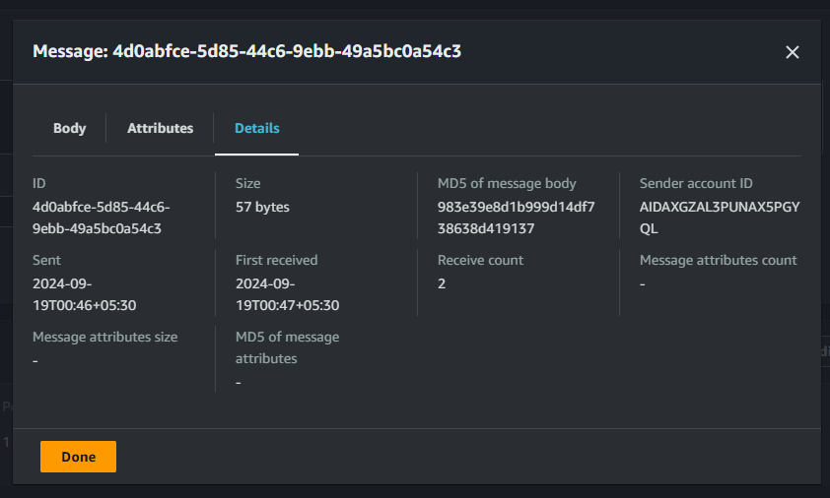

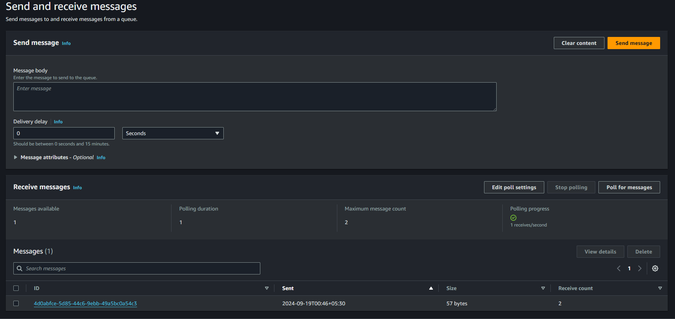

**Using AWS CLI:**

1. **Send a Test Message to SNS Topic:**

* aws sns publish --topic-arn arn:aws:sns:us-west-2:495599737832:MyTopic --message "Hi This is My Topic SNS Message"

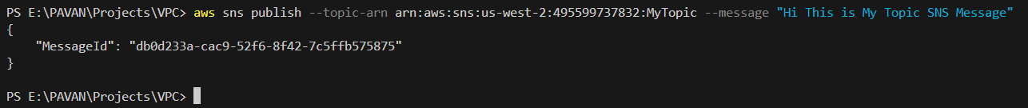

1. **Receive the Message from SQS:**

* aws sqs receive-message --queue-url https://sqs.us-west-2.amazonaws.com/495599737832/MyQueue



